

Final Report

|  |
| --- |
| School of Computing  Faculty of Engineering |

Procedural Modelling of Urban Cities

Nikolay Dimitrov Slavev

Submitted in accordance with the requirements for the degree of  
BSc Computer Science

**2018/2019**

**40 credits**

The candidate confirms that the following have been submitted*:*

|  |  |  |
| --- | --- | --- |
| **Items** | **Format** | **Recipient(s) and Date** |
| *Project Report* | *PDF* | *VLE (01/05/2019)* |
| *Project Report* | *Physical Copy (x2)* | *SSO (01/05/2019)* |
| *Source Code* | *Online Access (Appendix)* | *Supervisor, assessor (01/05/2019)* |
| *User Manual* | *PDF (in Appendix)* | *Client, supervisor (01/05/2019)* |
| *Video Demo* | *Online Access (Appendix)* | *YouTube (01/05/2019)* |

Type of Project: Exploratory Software

The candidate confirms that the work submitted is their own and the appropriate credit has been given where reference has been made to the work of others.

I understand that failure to attribute material which is obtained from another source may be considered as plagiarism.

Signed By:

© 2019 The University of Leeds and Nikolay Dimitrov Slavev

# Summary

Procedural modelling is a category encompassing a number of techniques for 3D modelling and texturing following a set of rules in computer graphics. That way, unlike all other modelling techniques which at some point require algorithms for data management and storage as well as model editing via user inputs, a rule set aims to provide the necessary requirements to create a model. Thus, a great amount of complexity, intricacy and believability can be achieved through implementation of simple rules if object patterns are analysed correctly. This is often the case when it would be too cumbersome to create models like architecture, plants and landscapes with generic modelling tools.

In this paper, we address the architectural modelling approach and more specifically the urban city problems in computer graphics. Every urban area poses a number of challenges encompassing population density, environmental influences, building aesthetics and street transport modalities for which adequative planning is essential and requires data [cityEngine]. Doing all of that manually leads to error-prone, costly and time-consuming development. On the other hand, complete modelling automation still remains a challenge due to the diversity, size and scale of the details required. Following hypothesis and algorithms cannot fully predict cases of historic and cultural street objects as well as junctions and buildings. As a result, the aim of this project is directed towards a procedural modelling of virtual cities attempting to combine the benefits as well as rectify the drawbacks of both manual and automatic generation. Users would be able to start and later edit a randomly generated or already existing street network as well as interact with a real geographic street map of their liking. That way, the clumsy manual modelling and the risk of fully relying on automatic generation would be reduced. Such software would benefit industries in the field of geodesign, urban planning, game development and film production.

# Acknowledgements

Tom Kelly – supervisor, fully supported me, answered any questions I had, great at quickly and effectively explaining difficult concepts, taught me ?, guided me through the ?, always positive, knew how to motivate by outlining the benefits of the project and how it could be expanded in the future

Hamish – helped me choose the most appropriate project for my skills and the one I would enjoy the most

ReadOSM

*<This page should contain any acknowledgements to those who have assisted with your work. Where you have worked as part of a team, you should, where appropriate, reference to any contribution made by others to the project.*

*Note that it is not acceptable to solicit assistance on ‘proof reading’ which is defined as “the systematic checking and identification of errors in spelling, punctuation, grammar and sentence construction, formatting and layout in the text”; see* [*http://www.leeds.acuk/qat/documents/policy/Proof-reading-policy.pdf*](http://www.leeds.acuk/qat/documents/policy/Proof-reading-policy.pdf)*. >*

# Table of Contents

Summary iii

Acknowledgements iv

Table of Contents v

Chapter 1 Introduction 1

1.1 Context 1

1.2 Problem Statement 1

1.3 Goal 1

1.4 Objectives 1

1.5 Plan 1

1.6 Methodology 1

Chapter 2 Background Research 2

2.1 Input Layout 2

2.2 Streets 2

2.3 Junctions 2

2.4 Building Parcels 2

2.5 Subdivided Parcels 2

2.6 Buildings 2

Chapter 3 Planning and Methodology 2

3.1 Initial Plan 2

3.2 Methodology 2

3.3 Risk Assessment and Mitigation? 2

Chapter 4 Implementation 2

4.1 Input Layout 2

4.2 Streets 2

4.3 Junctions 2

4.4 Building Parcels 2

4.5 Subdivided Parcels 2

4.6 Buildings 2

4.6 Exporting 2

4.7 Camera 2

4.8 Editing 2

List of References 3

Appendix A External Materials 4

A.1 Level 2 Heading with ‘heading 2’ Style Applied by Pressing Ctrl Shift 2 4

A.1.1 Level 3 Heading with ‘heading 3’ Style Applied by Pressing Ctrl Shift 3 4

A.1.1.1 Level 4 Heading with ‘heading 4’ Style Applied by Pressing Ctrl Shift 4 4

# Chapter 1 Introduction

## 1.1 Context

Modelling and visualisation of large and complex systems such as cities is a great challenge in computer graphics. As technology constantly improves and computing power increases, competing industries strive for more detailed, scaled and realistic visualisations. Most of the media, games, films, advertisement and television keep relying on the traditional approach of increasing the working load to meet their large project expectations. Those additional resources increase the cost and time which could be allocated to researching innovative features and improving the content’s creation. Such resources could be spent on manually modelling the details of large urban environments resulting in error-prone, costly, repetitive and time consuming activities while precisely attempting to satisfy every detail of the nowadays compelling models[review]. An automated solution to large-scale city generation is a procedural modelling technique [Parish and Muller ¨ 2001; Wonka et al. 2003; Muller ¨ et al. 2006] that uses simple rule set repetitively based on hypothesis and algorithms to make assumptions and predictions on how a model is created.

Creating large urban models require knowledge of different man-made systems with streets and buildings being the most essential ones. That said, according to Parish and Muller ¨ [2001], street networks are the key to creating such models[tensor]. L-systems are an approach where starting from a single street, more street segments can be added procedurally to form a street network [Prusinkiewicz and Lindenmayer 1991] [Prusinkiewicz et al. 2003]. That approach has been highly adopted and used as a basis of many procedural modelling improvement attempts trying to overcome an outcome limitation which results in unpredictable outputs that doesn’t match user expectations. Many research papers have added additional user-control support targeting that issue by providing guidance to the generation in the form of land-water boundaries, population density, aerial and tensor fields imagery. Moreover, streets could have many properties one of which is curvature and the Manhattan hypothesis where a city is organised along three dominant orthogonal directions could not be adopted [Coughlan and Yuille (1999)].

Procedural generation of parcels is the next key component for creating a complete urban modelling pipeline which generation includes several major consecutive steps after the underlying terrain is present and the road network created.

The steps are:

- divide the space in between the roads into blocks

- divide the blocks into lots representing the boundary space a building occupies

- populate the lots with buildings or other urban structures

The modeling and visualization of large-area cities using computers has become feasible with the large memory, processing and graphics power of todays hardware. [cityEngine]

## 1.2 Problem Statement

Procedural modelling on an architecture scale can be adopted to meet a variety of scenarios most of which continue to be a challenge. Starting from the use of GIS data for the precise depiction of the 3D world’s urban architecture to the development of random urban simulations, industries continue striving for the latest and most effective solutions. This paper tackles the challenge of modelling diverse urban environments of high complexity based on a hierarchical set of rules. Such environments can benefit projects where rapid development of large scenes is required. In the today’s world where scalability and complexity is a common necessity, doing everything manually requires large human labour introducing error-prone, costly and time consuming development that puts a barrier not only on established businesses but also on new fledgling companies trying to foothold into the market with their innovative solutions. Providing automation has been and continues being of high interest to companies and research facilities. A solution to that, addressed in this paper, is provided by fascinating techniques like L-Systems, fractals and generative modelling which make it possible to construct large scenes from small amount of rules where repetitive algorithm outputs does not need to be stored providing database amplification.

## 1.3 Goal

The project’s aim is to produce a procedural approach of city modelling that is primarily focused on street generation and secondarily on building’s architecture. This project will develop an exploratory software capable of automatically creating large 3D architectural scenes that rely on efficient rules and algorithms. To increase the user experience, diverse input options will be provided as well as a real-time editing functionality.

## 1.4 Objectives

In order to provide a thorough solution, milestones outline key project phases. These objectives are consecutively ordered representing the most common flow of procedural city modelling.

• Identify and select multiple ways of generating the street network (e.g. randomly, geographic data, existing file)

• Choose efficient technique for converting the network edges into street segments. Edges could be linear, quadratic or cubic Bezier curves with or without support nodes.

• Identify and implement an efficient algorithm to iterate over the network nodes and generate junction objects with respect to the intersection of edges and their joining point.

• Based on the street network solution, research and implement a technique for finding enclosed loops that will act as building parcels

• Considering the junction and street objects, implement a way that will store the building parcels without overlapping other objects.

• Find an algorithm which effectively divides the parcels into smaller blocks which will represent the allocated space of each building model

• Implement a simple rule for generating random buildings on every subdivided block

• Add a camera that can be rotated in any direction, zoomed in and out as well as moved forward and backward

• Add a real-time feature that enables adjustments to the street network

• Include an option that would export the model and make it ready for visualisation on other software products such as Blender and Sketchfab

## 1.5 Plan

Figure 1.1 shows a Gantt Chart of the overall project’s plan. The plan is very high level and only includes large topics which are necessary to meet the project’s deliverables criteria. It has an optimistic time scale with an expected end of coding implementations a month before the deadline. That is due to the intensity of other module materials expected to be delivered at the same time as the project. The last month would, therefore, be focused on lower risk tasks such as finalising the report and adjusting any minor inconsistencies.

|  |  |  |  |  |  |  |  |  |
| --- | --- | --- | --- | --- | --- | --- | --- | --- |
|  | Sept | Oct | Nov | Dec | Jan | Feb | Mar | Apr |
| Scope and Planning |  |  |  |  |  |  |  |  |
| Literature Review |  |  |  |  |  |  |  |  |
| Technology Review |  |  |  |  |  |  |  |  |
| Intermediate Report Writing |  |  |  |  |  |  |  |  |
| In-depth Research |  |  |  |  |  |  |  |  |
| Implement Model |  |  |  |  |  |  |  |  |
| Report Writing |  |  |  |  |  |  |  |  |

*Figure 1.1: Gantt Chart of the project’s plan*

## 1.6 Methodology

The exploratory nature of the project comes with a lot of uncertainty from which follows that changes might occur on a daily basis. A methodology known for its capability of adapting to change in a short-cycled manner is Agile. Therefore, the project’s development lifecycle will be based on it.

Each Sprint, which is a short Agile recursive timeframe, will not only involve development activities but also research ones due to my novel knowledge about the topic.

# Chapter 2 Background Research

The chapter is focused on examining industry and academic research papers that look into the identification and implementation of techniques applicable to the procedural modelling of urban cities.

A complete city encompasses an enormous amount of elements with different structure, attributes and complexity. M. Wegner, however, split the urban model into subsystems and noted that networks, land use and housing were among the slowest changing elements (M. Wegner, 1988). Later, Parish and Muller identified the street network as the key subsystem to creating an urban city (Parish and Muller, 2001). Considering those findings, the paper would, therefore, only analyse the most irreplaceable and essential elements – street networks and buildings. The former would be more substantial, and thoroughly examined due to its key role in the development. Such type of city generation can be achieved through a number of techniques addressing the creation of roads, lots and building structures (review).

The background research would examine the various procedural modelling techniques and provide further context to the project. It would measure the feasibility of the different algorithms as well as provide understanding of issues that might arise. After that, adequate planning, methodology and risk mitigations can be decided.

## 2.1 Street Network Layout

Fractals, L-Systems, Perlin Noise, Tiling and Voronoi are procedural methods which have been largely applied to natural objects and textures. Researchers, however, discovered that such methods can also be applicable to many other sectors one of which being the architecture of urban cities (review). This section, therefore, reviews and evaluates the various procedural techniques that researchers managed to adapt to the context of urban city areas.

revealing of patterns [cityEngine]

Grammar-based generation of models (especially L-systems) are employed in computer graphics mainly to create plant geometry [26]. L-systems have evolved into very sophisticated and powerful tools [20, 27] and have been extensively used in the modeling of plant ecosystems described in [8]. [cityEngine]

Procedural techniques have been applied successfully in the generation of numerous complex phenomena in computer graphics and have proved beneficial for a number of reasons

### 2.1.1 Extended L-System

Originally, the L-System was developed to model the growth and development behaviour of plants and later of various organisms. The theory behind it consists of alphabet symbols able to make strings. Those symbols get influenced by a collection of production rules which expand each symbol into large strings and with a special mechanism get translated into geometric structures. Aristid Lindenmayer defined that technique in the form of a formal grammar depicted as:

***G = (V, ω, P)***

where

V – is the alphabet defined by a set of symbols

ω – is the axiom (start position) represented as a string of symbols defining the initial state

P – is the set of production rules specifying the way variables can be recursively replaced to generate new symbol sequences

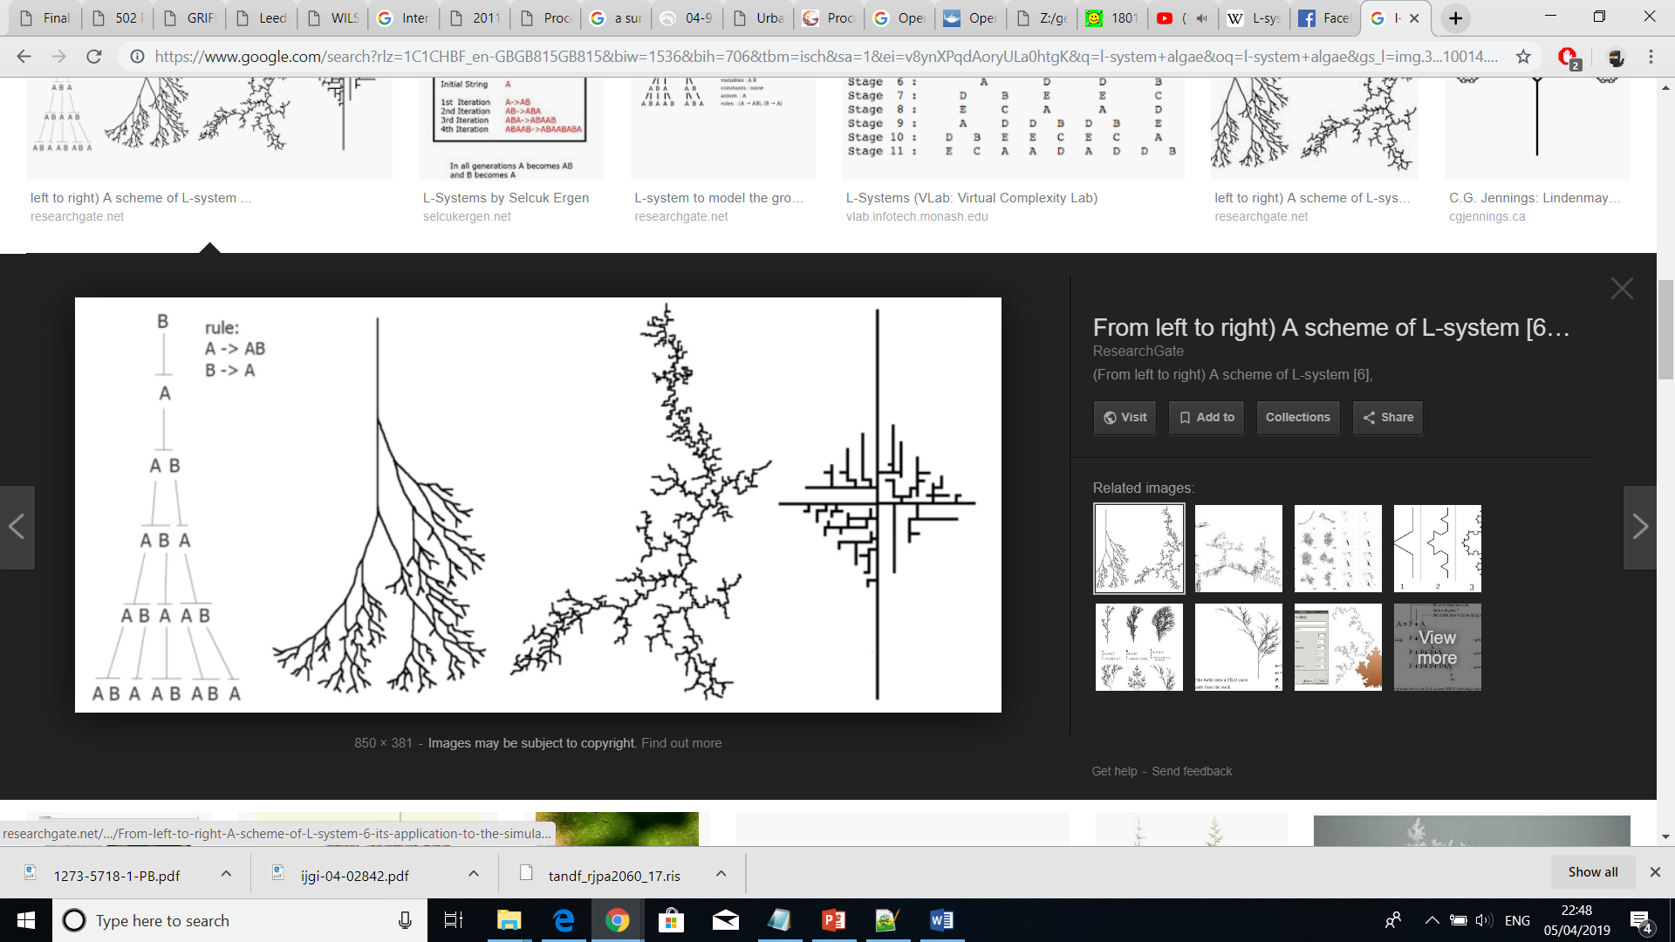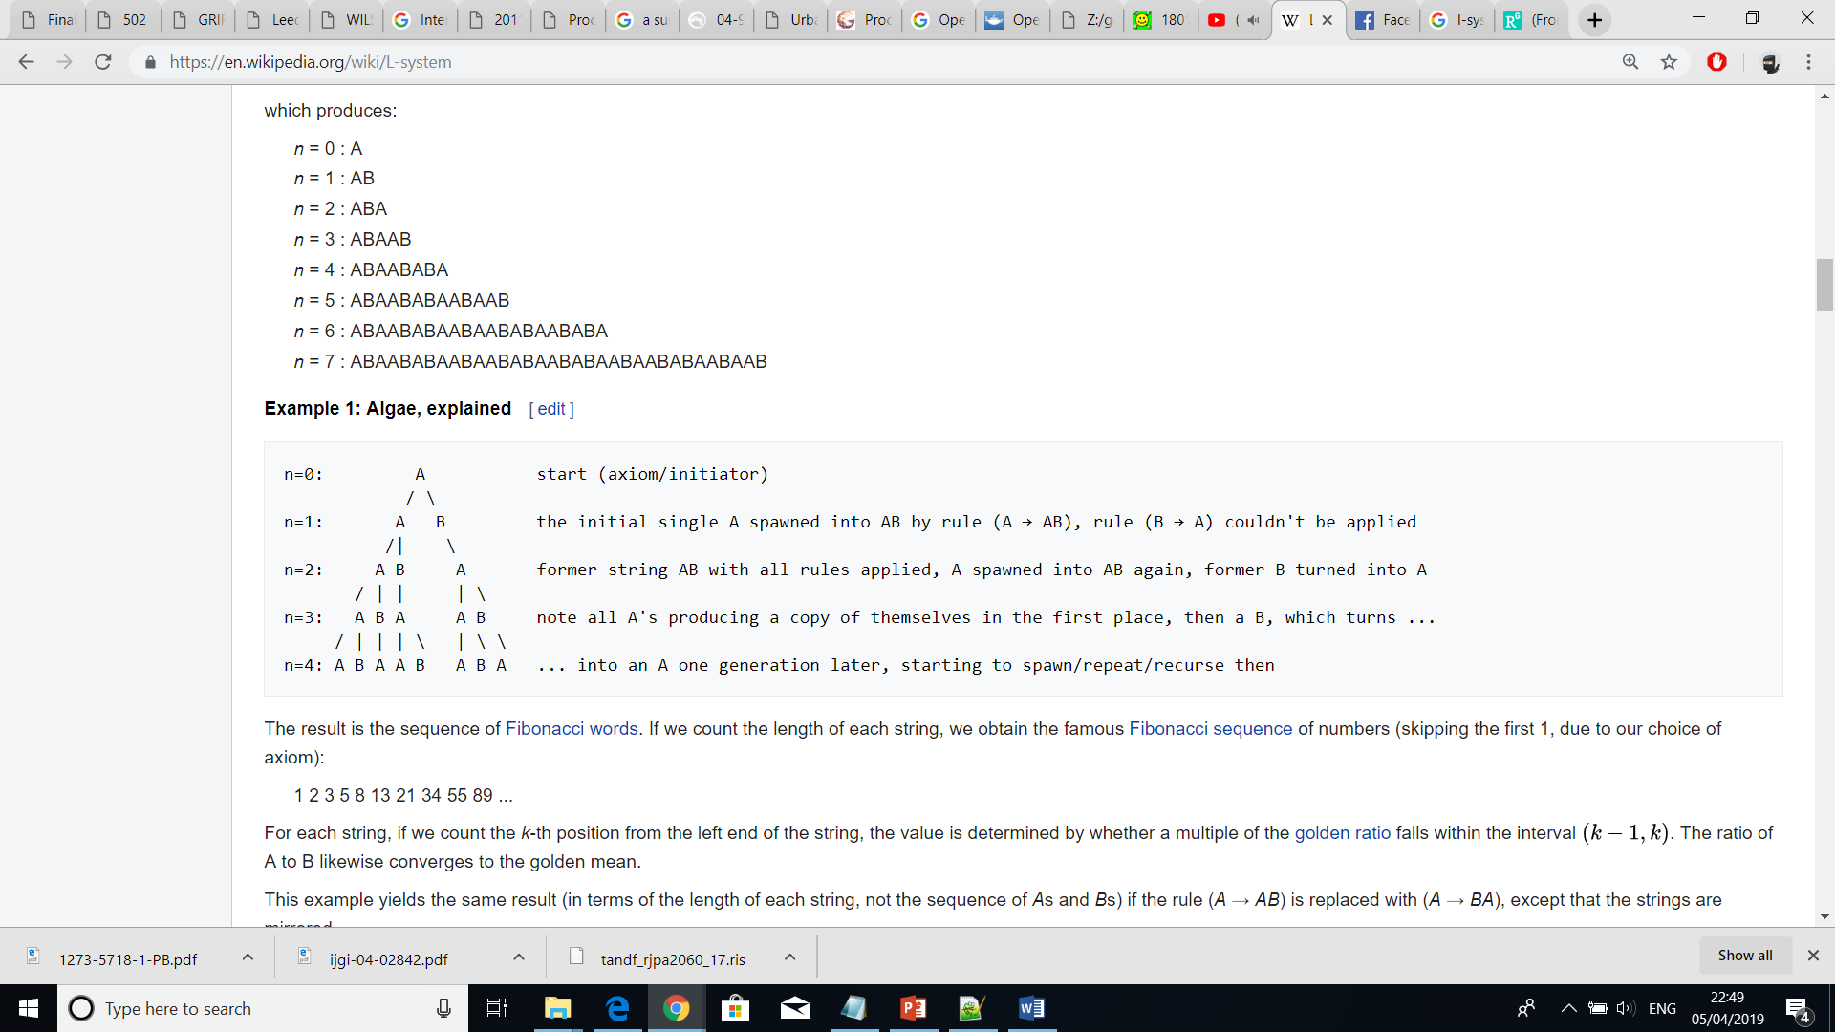*Simple Example:*

variables : A B

constants : none

axiom : A

rules : (A → AB), (B → A)

Parish and Muller extended the L-System with the aim of applying it to a street network. The extended version had the additional feature of forming loops where intersecting branches were present. That changed the topology and turned the tree-like structure into a netlike one.

*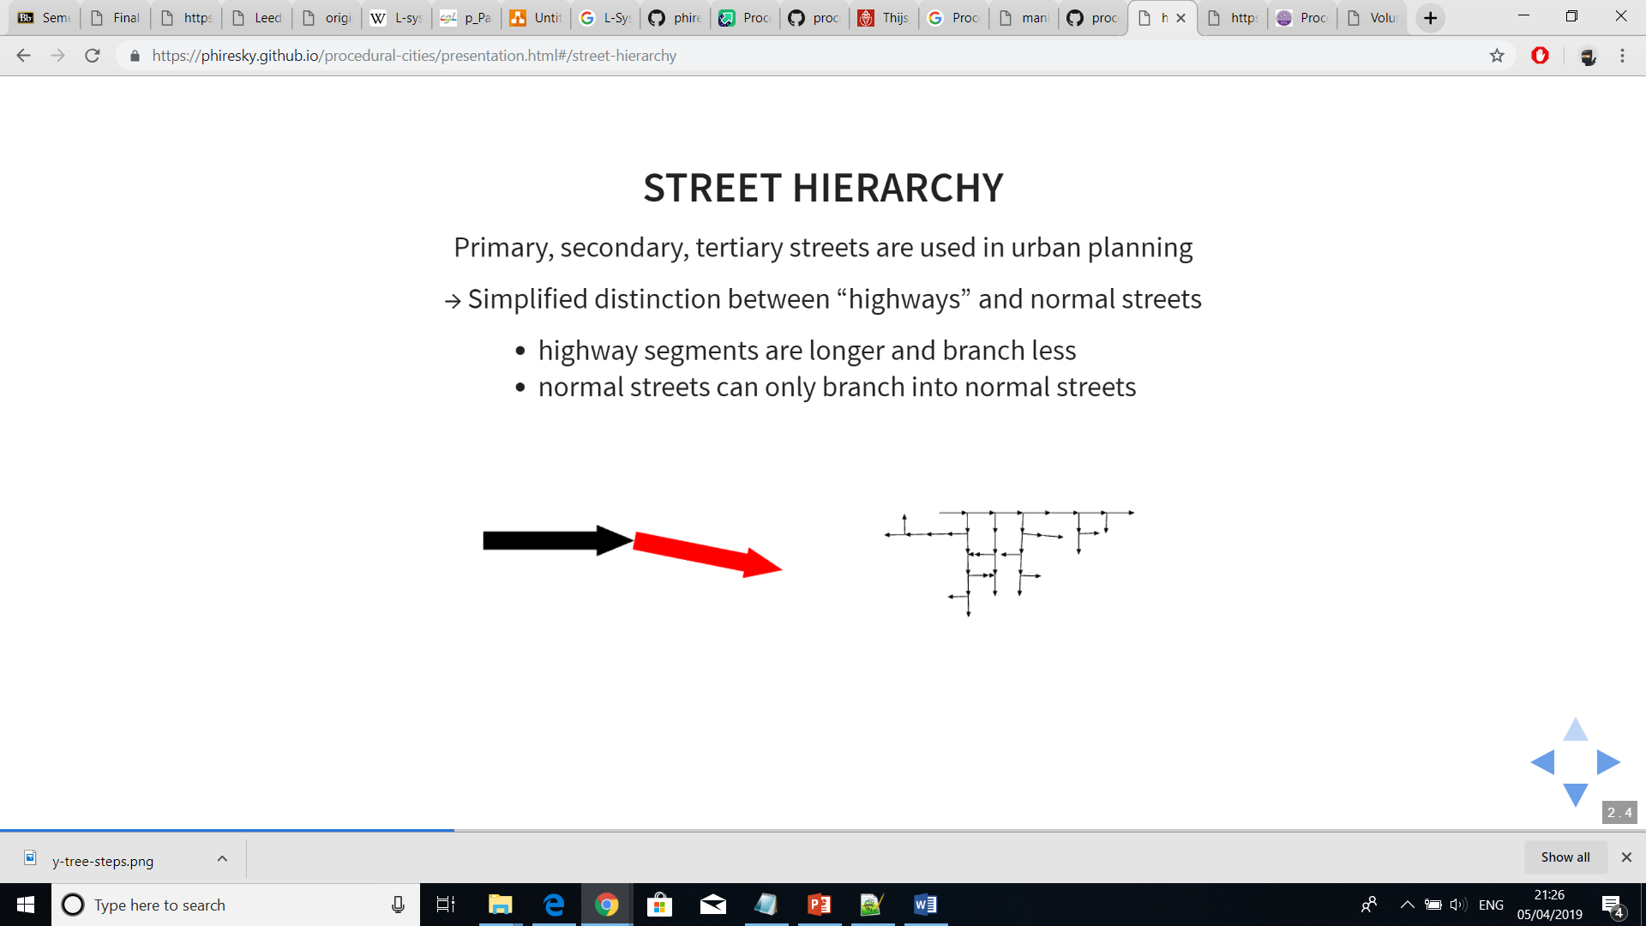Example of L-System with loops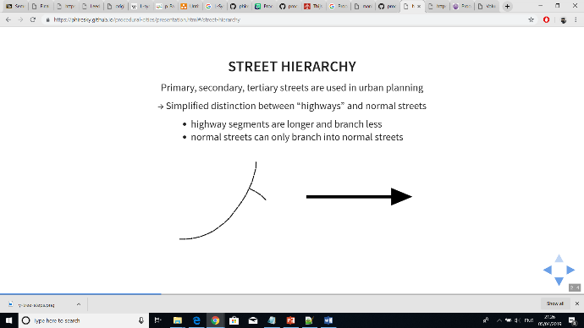*

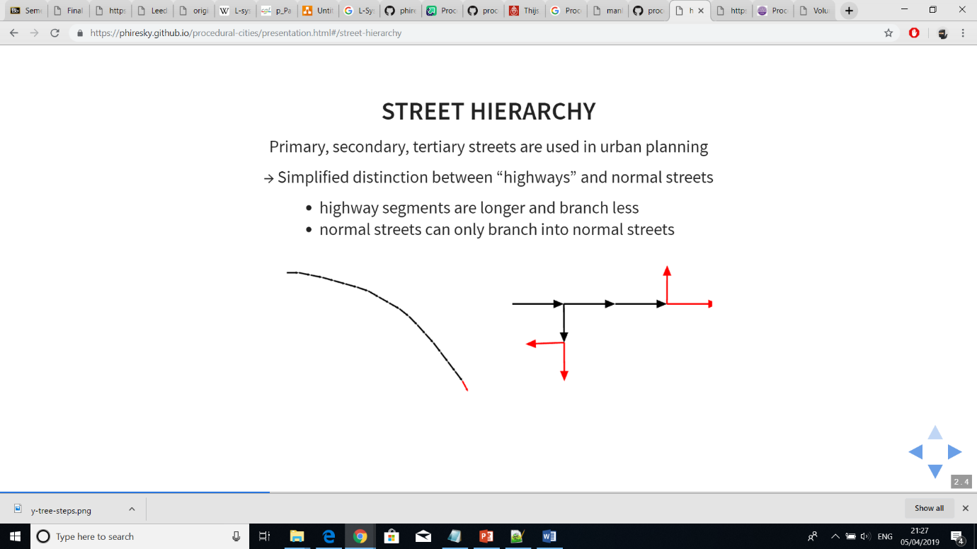

Additionally, the set of production rules got represented by Global Goals and Local Constraints:

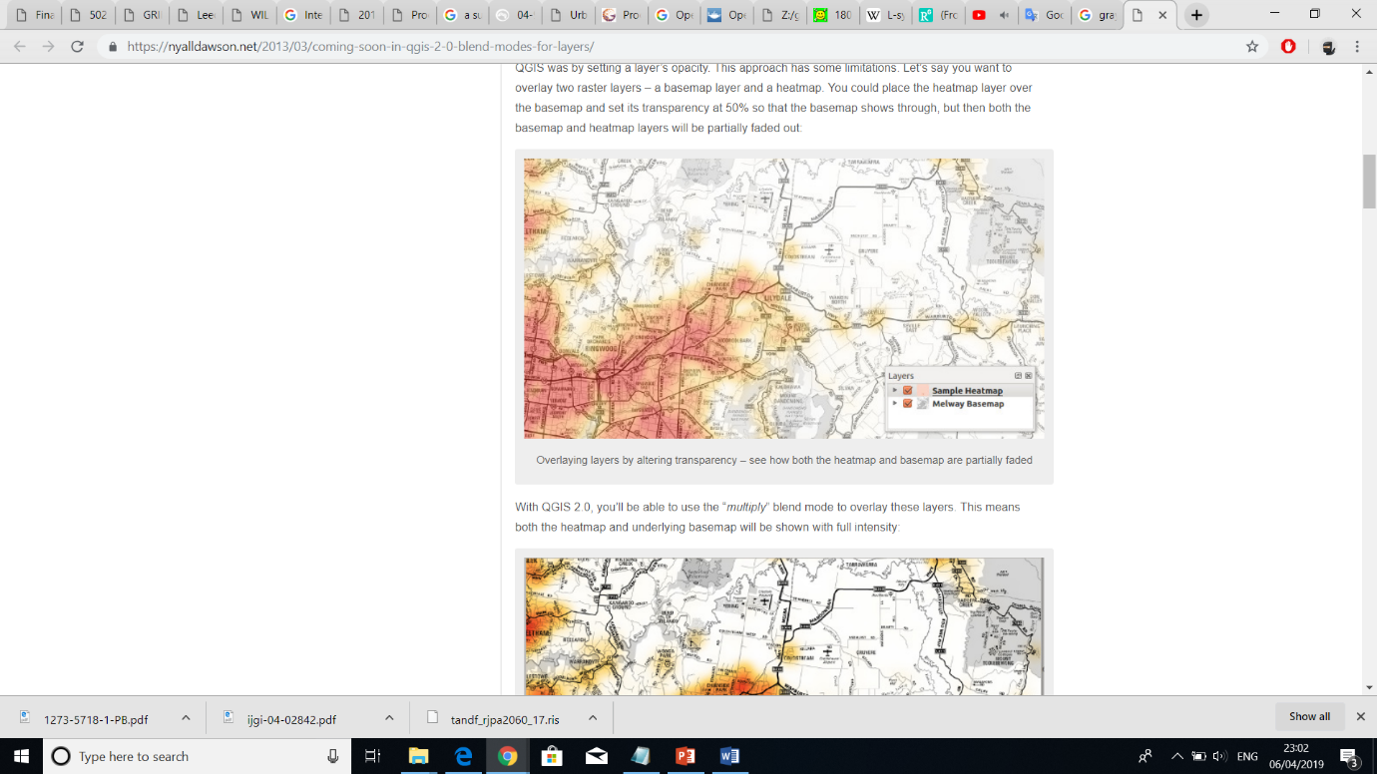Global Goals – can define road style, population density, elevation, land & water boundaries and zone types

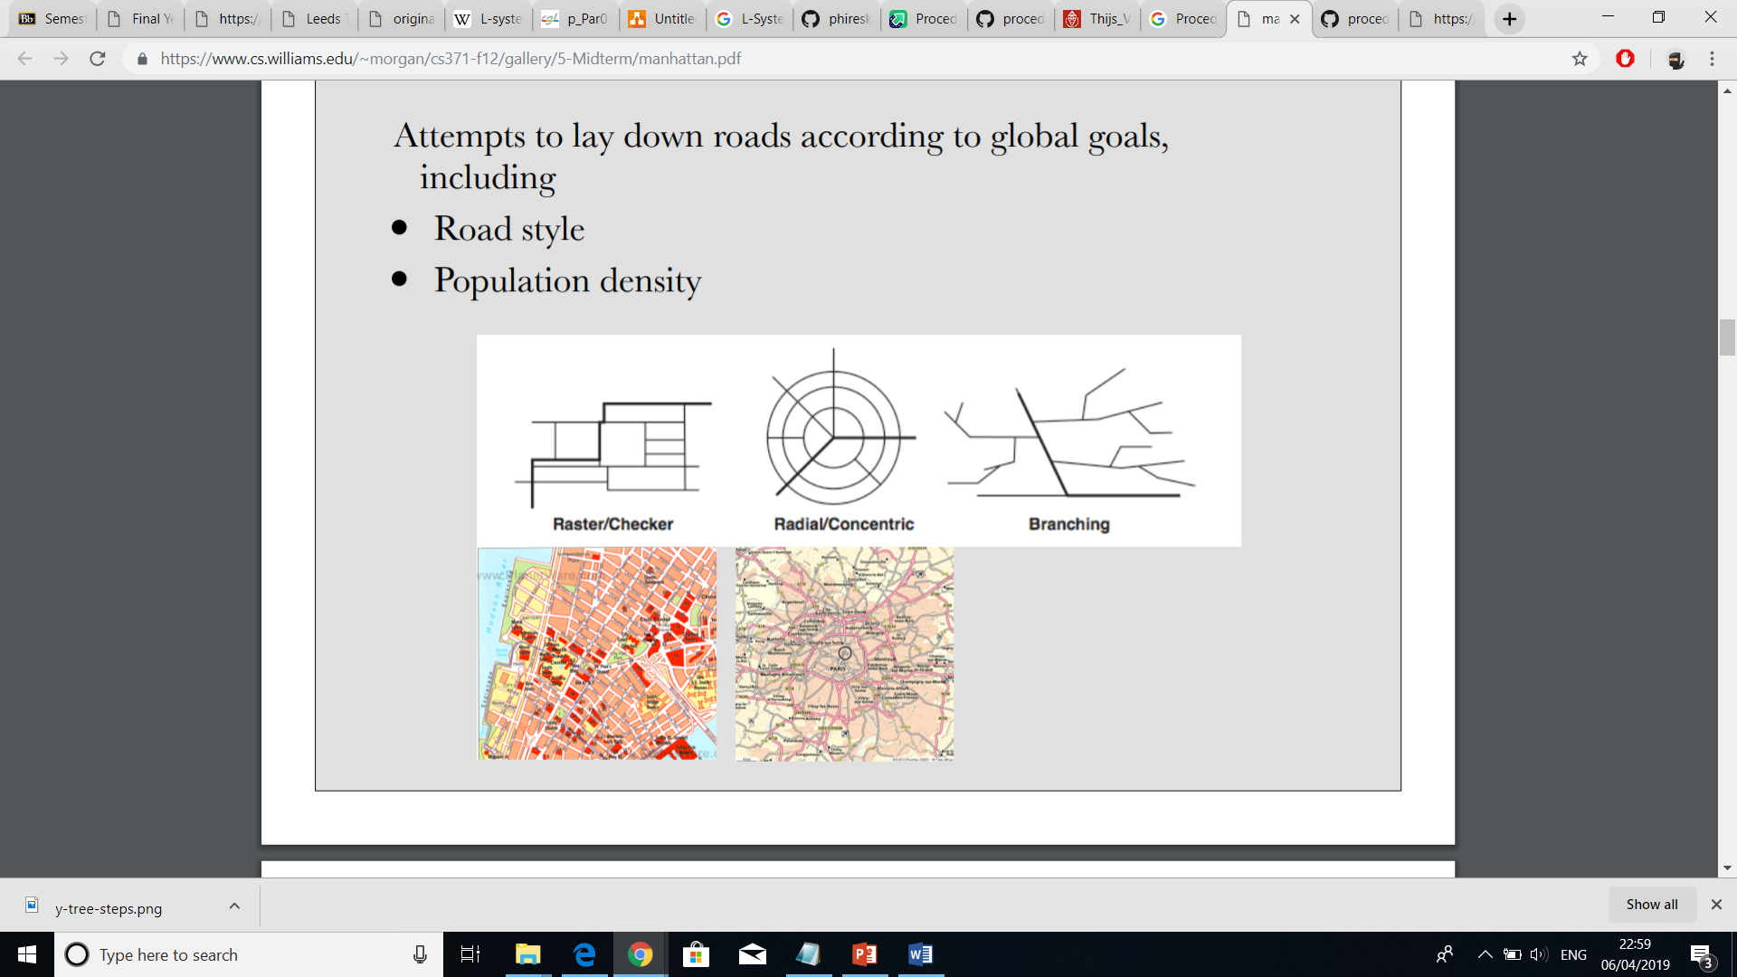

Local Constraints - prevent roads from crossing water and entering parks as well as modify road endpoints based on intersections with other roads within a given radius.

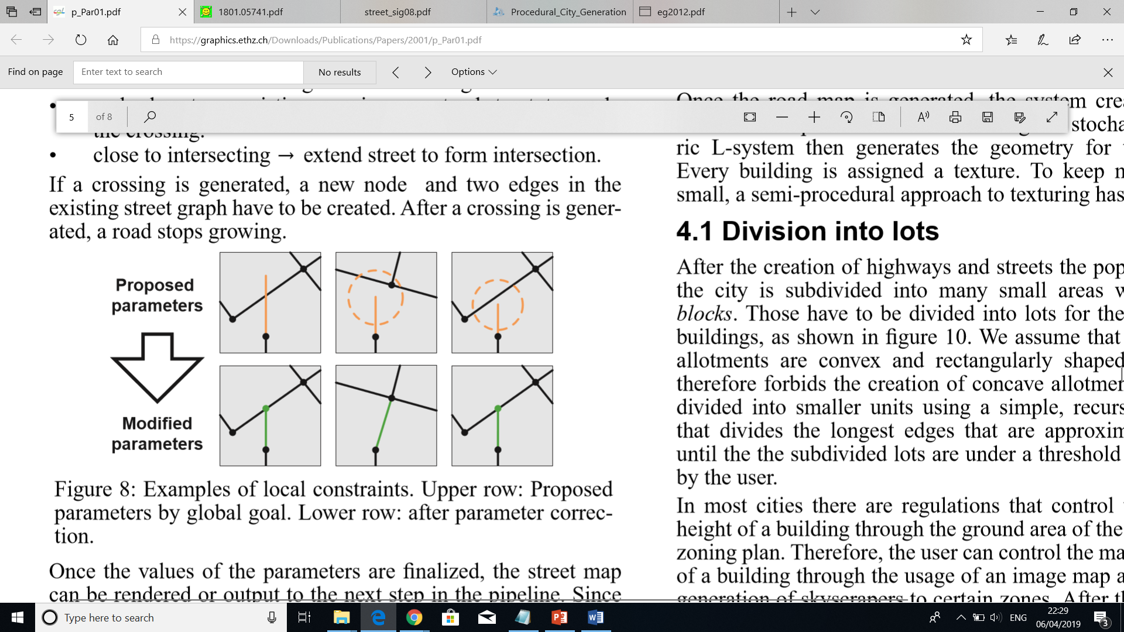

Example after applying global and local constraints considering highways and normal streets

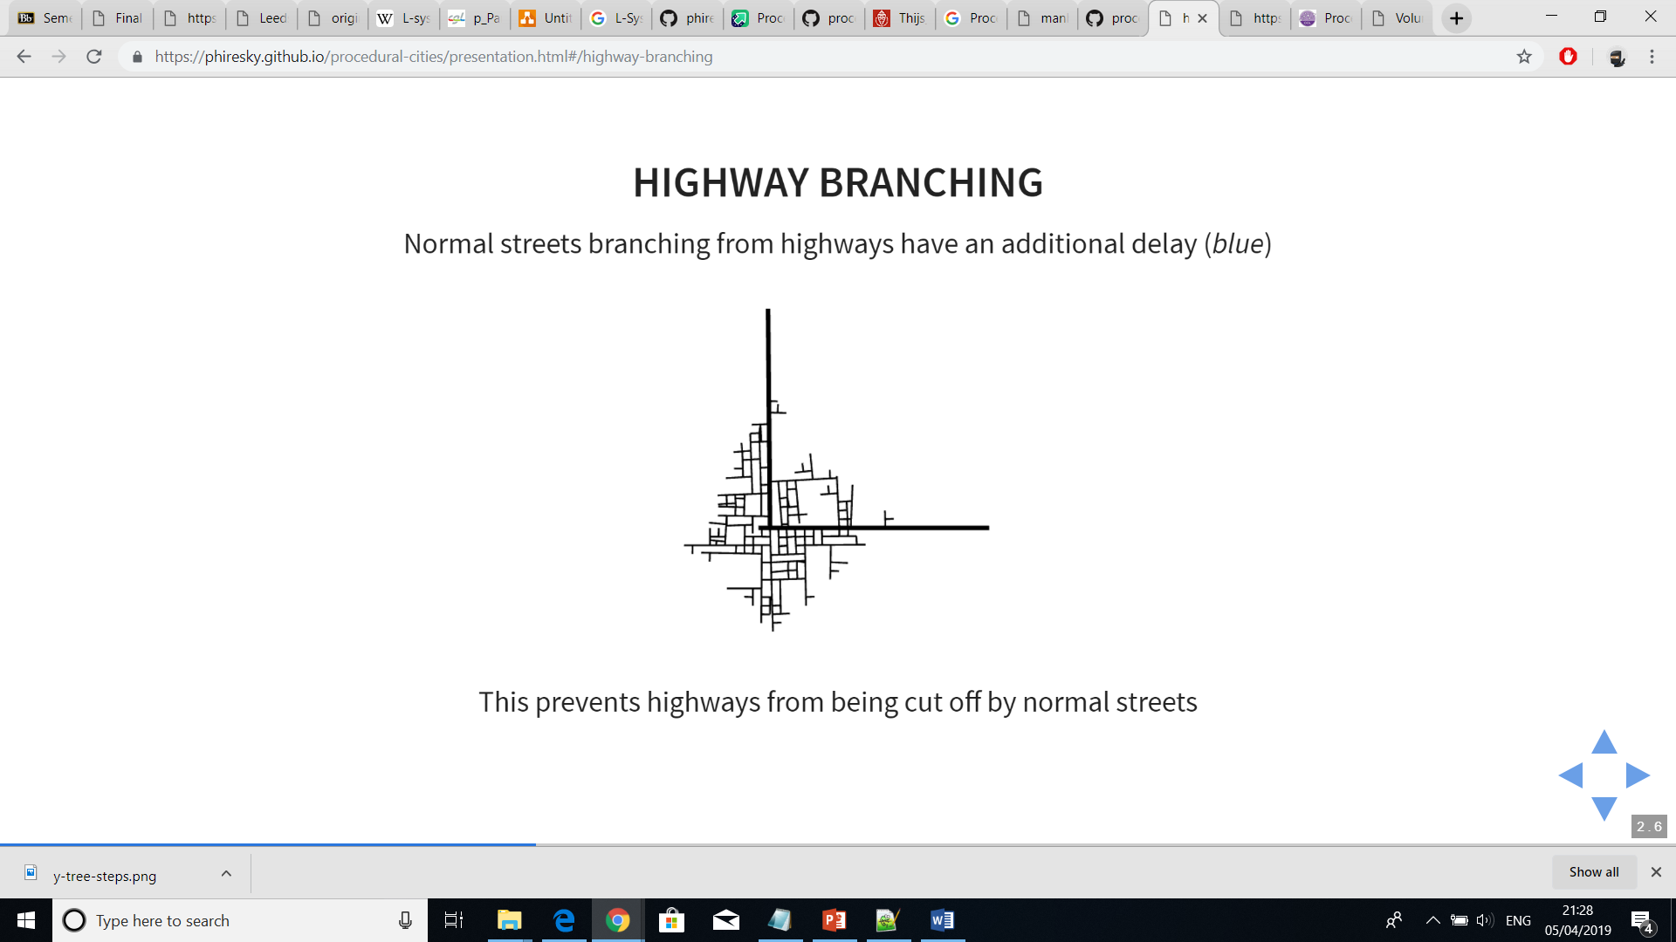

Road Patterns – Basic, New York, Paris, San Francisco – follow population density; follow angle and maximal length and width of a single block, all highways and streets form a rectangular blocks; highways follow radial tracks around a centre which is calculated or set manually; follow to route with least elevation areas with large differences in ground elevation

projects that rely on aerial imagery [15] [4, 32] [cityEngine]

revealing of patterns [cityEngine]

films, games, simulations etc [cityEngine]

Roads are the transportation medium for the urban population distributed over the area. L-systems have been used in a similar application [20], support branching very well and have the advantage of database ampliﬁcation [30]

When an area with no population is reached, the streets stop growing

We have also been inspired by approaches to model ice ray lattice design [Stiny 1977], mortar in brick layouts [Legakis et al. 2001], diffusionlimitedaggregation[WittenandSander1981],andcracks in Batik renderings [Wyvill et al. 2004]. However, the similarities of their appearances to street layouts are rather remote. A very interesting class of layout algorithms uses Voronoi Diagrams [Berg et al. 2000] of (randomly) distributed points. This idea is extended to generate textures [Worley 1996], mosaics [Hausner 2001], fracture patterns [Shirriff 1993; Mould 2005], and even some street patterns [Sun et al. 2002; Glass et al. 2006].

### 2.1.2 Tensor Field Imagery Guidance

A different approach to L-Systems was proposed by Guoning Chen where the generation of roads was guided by a tensor field. It was observed that the two tensor hyperstreamlines, one following the major eigenvector field and the other the minor eigenvector field, could guide the generation of streets. Additionally, a better and wider control of the street network was supported due to the tensor field properties. Users were able to interactively adjust the network through applying a combination of modelling operations like brush stroke, smoothing, constraints, noise and rotation on the tensor field imagery.

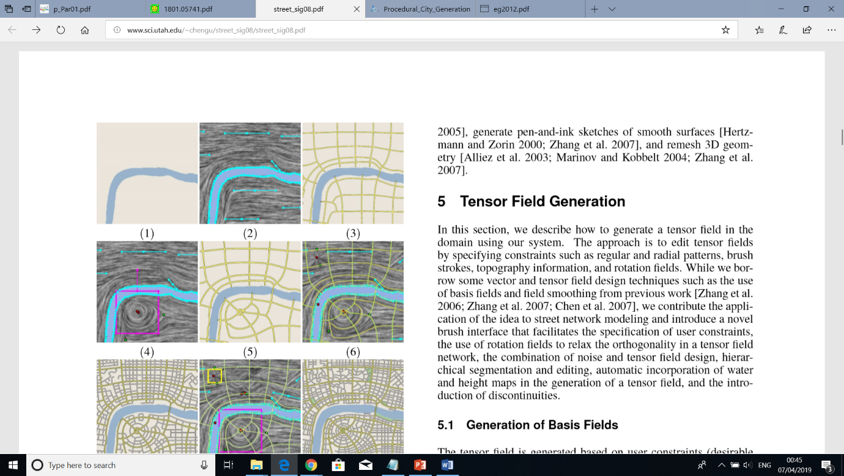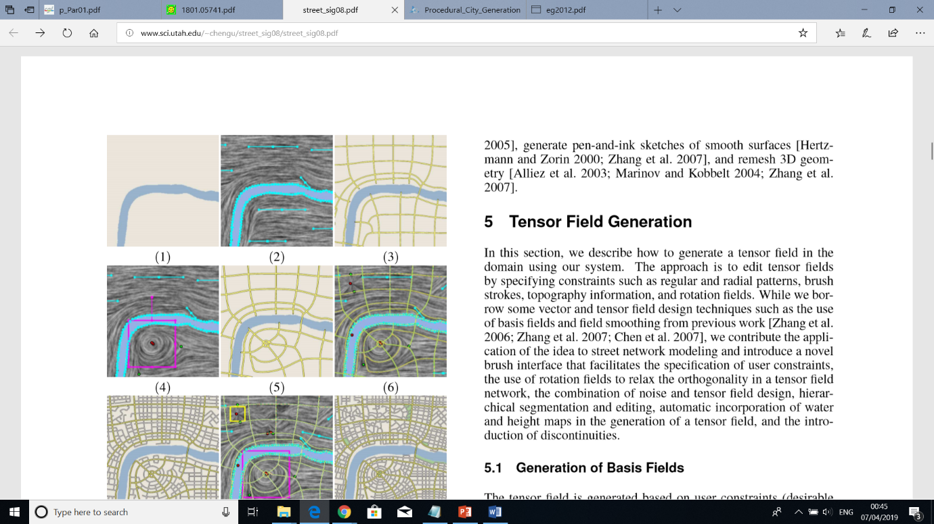

A tensor field is a function that associates every point of typically an Euclidean space with a tensor. In the paper by Chen, each tensor referred to a 2x2 matrix of the form

 where R >= 0 and θ E [0, 2P)

The major eigenvector was { | λ != 0} and the minor { | λ != 0}

However, it should be noted that major and minor eigenvectors are not related to major and minor roads. The different road types have their own instances of both tensor field hyperstreamlines. A detailed explanation can be seen in ?(need reference).

### 2.1.3 Voronoi Diagram

Voronoi diagram is another technique that was demonstrated as a way of procedural generation by S. Worley (A Cellular Texture Basis Function) and later found its usefulness in a variety of fields, one being the street network geometry (review, african).

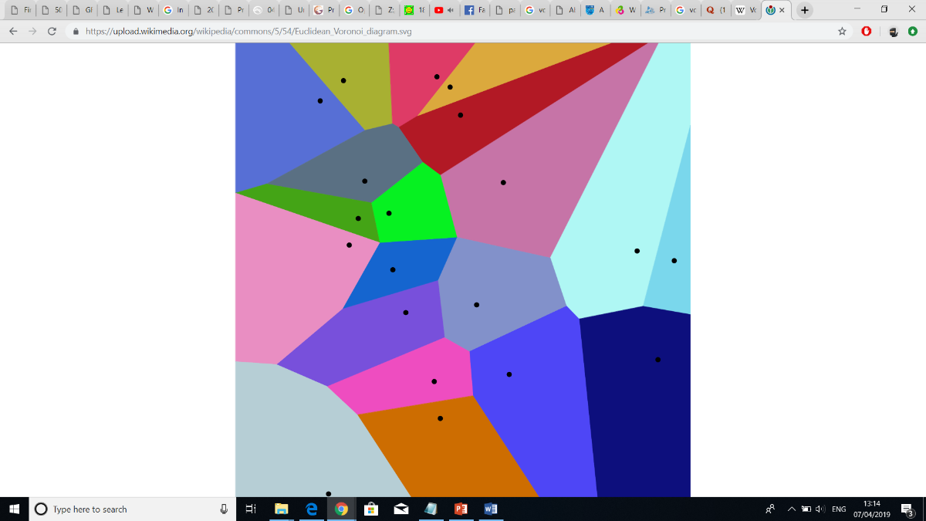It partitions a plane into convex polygons called Voronoi cells based on a set of points called seeds. The partitioning is made in such a way that each polygon contains exactly one seed and the distances between a border and a seed of neighbouring Voronoi cells is the same [Preparata and Shamos 1985]. That way, if a random point is inside a certain Voronoi cell, it will be closer to that polygon’s seed than to any other one.

In the context of procedurally generating street networks, (african) and (the other) interpret the edges of all polygons as streets. (african) even proposed a combined solution where Voronoi was applied to model only major streets and other techniques such as subdivision, Perlin noise and L-Systems generated the minor ones.

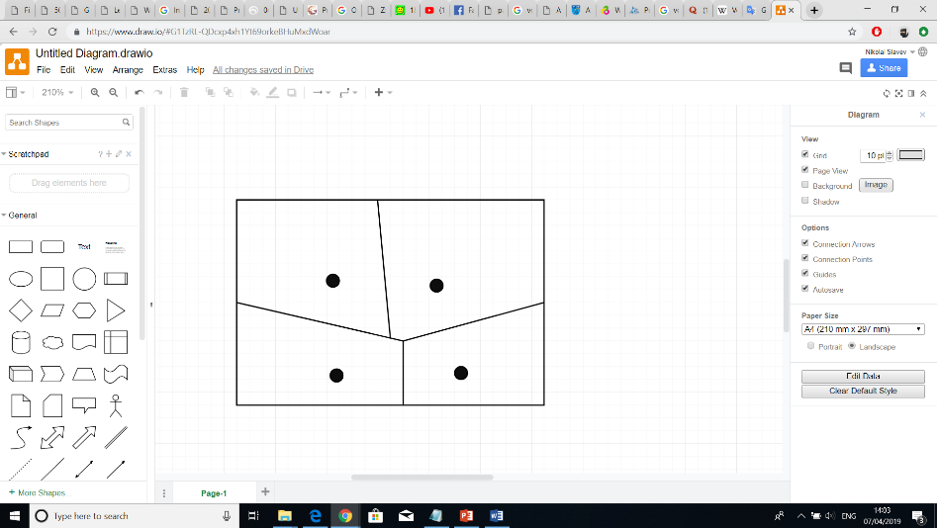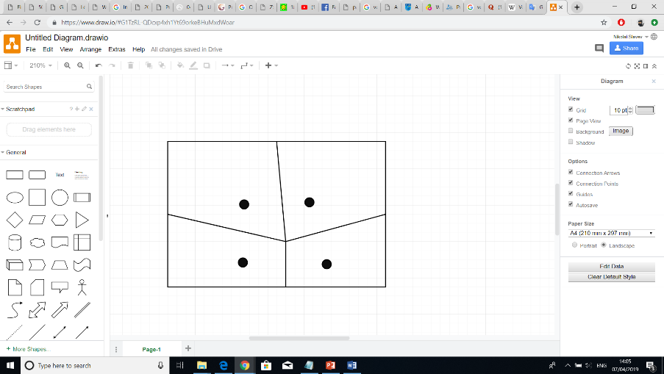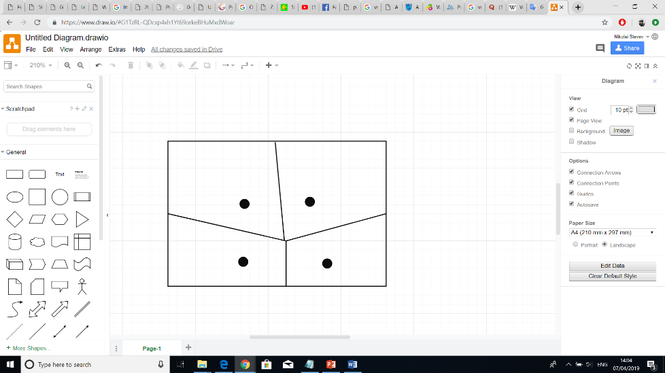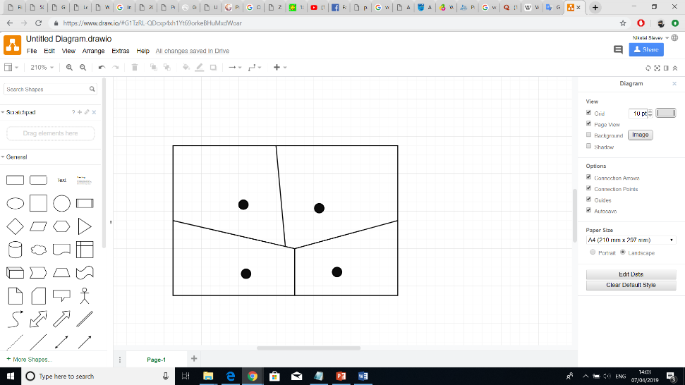An interesting feature of Voronoi diagrams is that if a random point is placed on a cell’s edge, it can have at most three seeds with the same distance to that point. Therefore, a street junction can only join three street segments. Possibilities for mitigating that limitation are to either join together edge intersections that are close to each other (*Picture 2*) or adjust the seeds to visually imitate that more than three streets are joining together (*Picture 1*).

### 2.1.4 Random Planar Graph change with sth else

### 2.1.5 Geographic Data

A recent paper adapted the use of GIS data to create a street network model (geo). The real geographic data consisted of polylines showing the location of each street. Using those polylines as well as information about street type, road surfaces with different width were created. The point where streets join was modelled as a junction object and any fully enclosed areas were treated as building parcels.

The paper, however, aimed at approximating road surfaces (e.g. width, lanes, markings) junction objects (e.g. corner arcs, shape) and building parcel areas as close to the real ones as possible. Using hypothesis and the GIS street data, typical street networks were correctly generated but rare cases failed. Regardless of that limitation, a substantial amount of successfully approximated cases was covered and the rare occasions of unsuccessful hypothesis was easily determined and corrected with editing tools.

Overall, using GIS data as a basis for street generation added valuable benefits such as:

- realism - the city looks realistic because it is based on a real geographic data

- scale - the size can be large or small, depending on the extracted region

- variation - diverse street variations can be tested and they won’t be unrealistic

proved that

a nice technique for determining the location of streets

tracking the shape and location of the streets

A kinematic rule of thumb attempted to estimate the radius of the corners where streets intersect and form junctions.

first hypothesis – streets were adapted so that vehicles can drive conveniently at a given speed that depends on the street type. Streets tend to drive more slowly on narrow residential streets than on city fast lanes.

second hypothesis – given a speed, a vehicle is limited in the turns it can make. Considering that the vehicle follows an arc of circle trajectory, a radius that is too small would produce a dangerous acceleration and would be uncomfortable. Find the radius r associated with a driving speed s through empirical function f(s) -> r. (SETRA, 2006)

First, we observe that street and urban objects are structured by the street axis

This means that cornerstone in an intersection does not form sharp right turns that would be dangerous for vehicle tires. The most widespread cornerstone path in this case seems to be the arc of a circle, as it is the easiest form to build during public work

Kinematic rule of thumb – attempt to estimate the radius of the corner in the intersection. They give a reasonable best guess result and don’t mean that the streets were made following them

estimate the turning radius based on the assumption that it depends on the type of road.

Then, we use a basic hypothesis and a simple road model to generate more detailed data. We use a widespread street network model, where the skeleton is formed by street axis and intersection forming a network.

Real life streets are extremely complex and diverse; we do not aim at modelling all the possible streets in all their subtleties, but rather aim at modelling typical streets with a reasonable number of parameters.

## 2.2 Streets

Urban street geometry is very diverse encompassing examples of linear, curvilinear and a combination of both streets. To accurately display such diversity in the computer graphics world, however, complex algorithms are required. This subsection will reveal the possible approaches of rendering street examples as well as techniques for turning street lines into larger segments and later tessellating them.

### 2.2.1 Street Axis

A computer graphics solution to finding the trajectory of lines whether curved or straight is by using Bezier curves. Such curves are defined by a set of control points P0 through Pn where the first and last points correspond to the start and end points of the curve. From that follow that:

when n=1, the curve is linear

when n=2, the curve is quadratic

when n=3, the curve is cubic

Furthermore, a combination of multiple Bezier curves can be joined together to form a Bezier spline. If that spline follows certain properties like smoothness and identical curvature at the breakpoints, it gets called a B-Spline.

The linear Bezier equation simply defines a straight line between two points as follows:

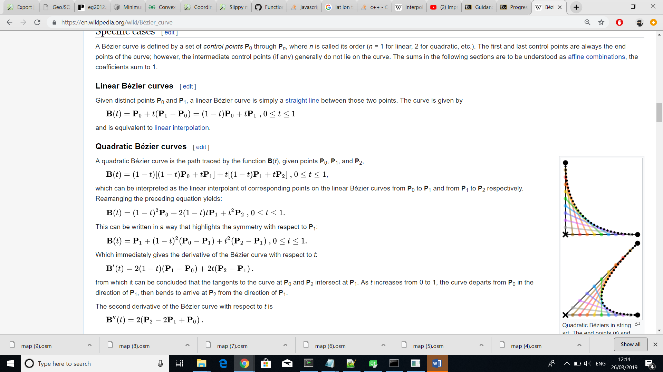

where B(t) gives the path between P0 and P1 depending on the value of t.

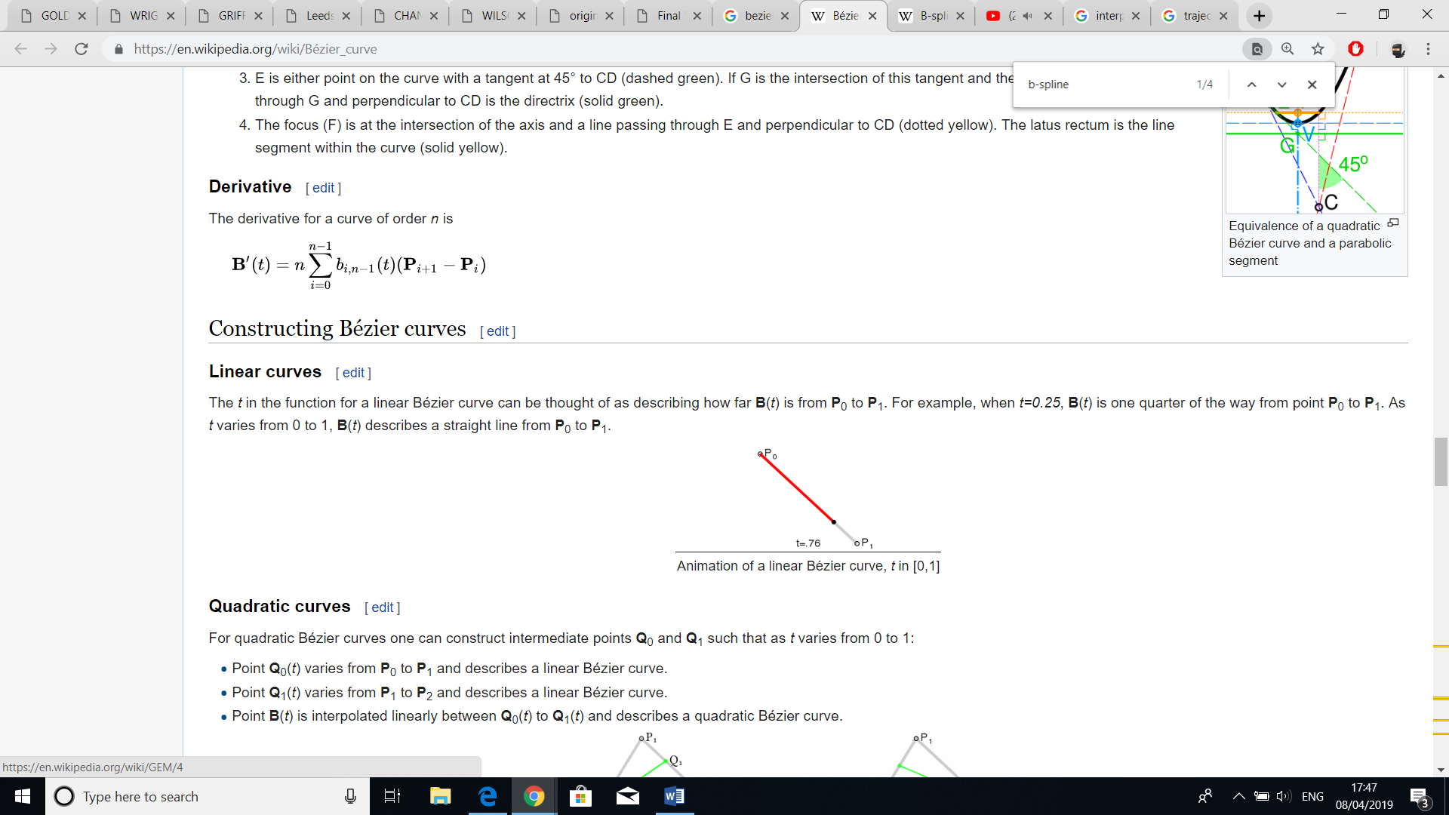

The quadratic equation uses three points P0, P1 and P2



but can also be interpreted as three linear interpolations from P0 to P1, P1 to P2 and then the resulting point from the first equation with the resulting point from the second.

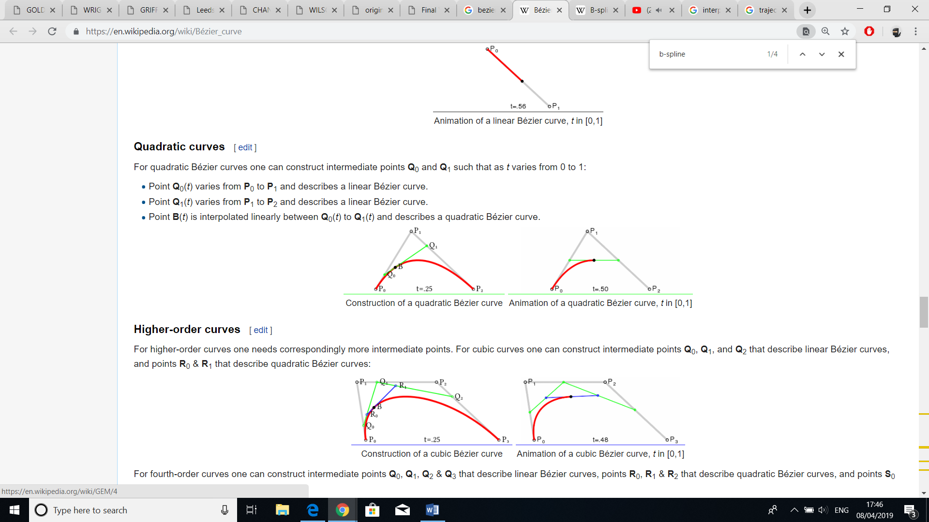

A cubic Bezier curve is defined in a similar way except that four points are used.

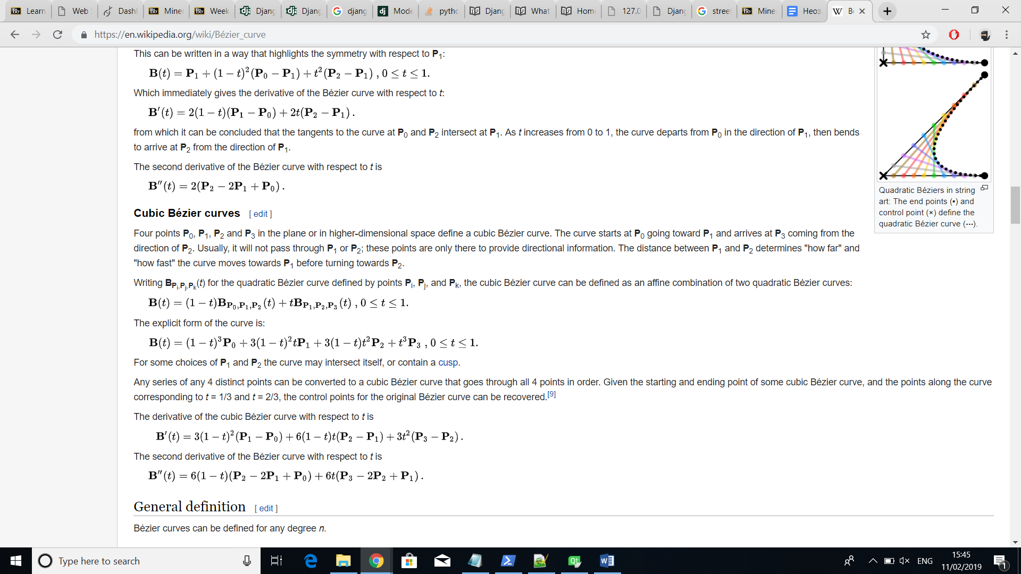

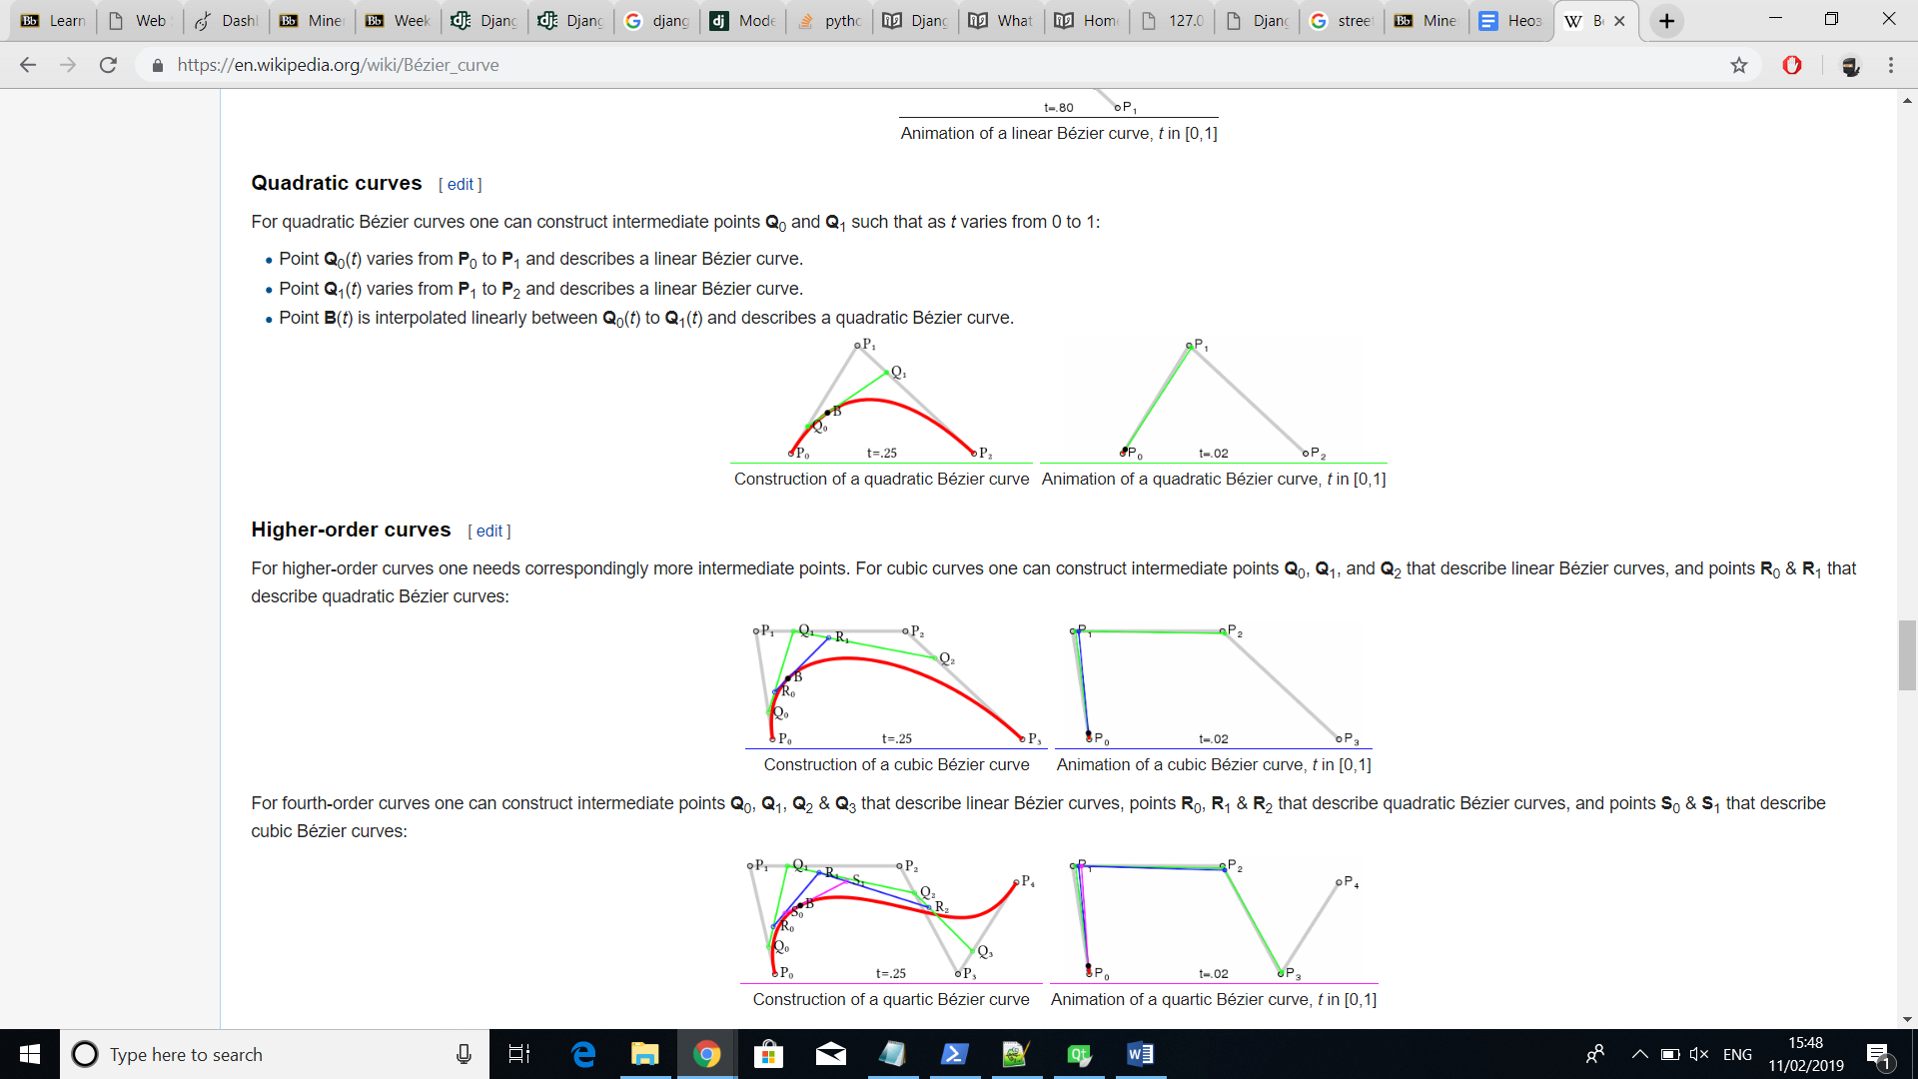

B-Spline

…

### 2.2.2 Street Segments

Using Bezier curves enable the creation of diverse lines in computer graphics but a single line is not sufficient to represent a complete street. The algorithms regarding computation of street networks only determine the middle line of the street also called street axis. What we are after, however, is a street not only with length but also with width. (there is better expln)

Turning a straight line into a rectangle is simple. Start and end points can be offset by a predefined amount using the direction of both clockwise and counter-clockwise normal unit vectors. Then, tessellating the object as a polygon using the four new points.

(pictures showing that)

Curved streets, on the other hand, would consume more computational power since offsetting them requires more such iterations and finding the normal vectors is not as straightforward. For each point, that has been found while either computing the quadratic or cubic Bezier equation, the tangent of that point needs to be computed. Based on the tangent, both normal vectors can be found. Doing that for all points and simultaneously summing each normal vector with its corresponding point will give the contour of the curved street segment.

(curve pictures with normal and tangents)

However, in case of a really small curve axis the inner offset curve would intercept itself causing the street segment to fail. (how to fix).

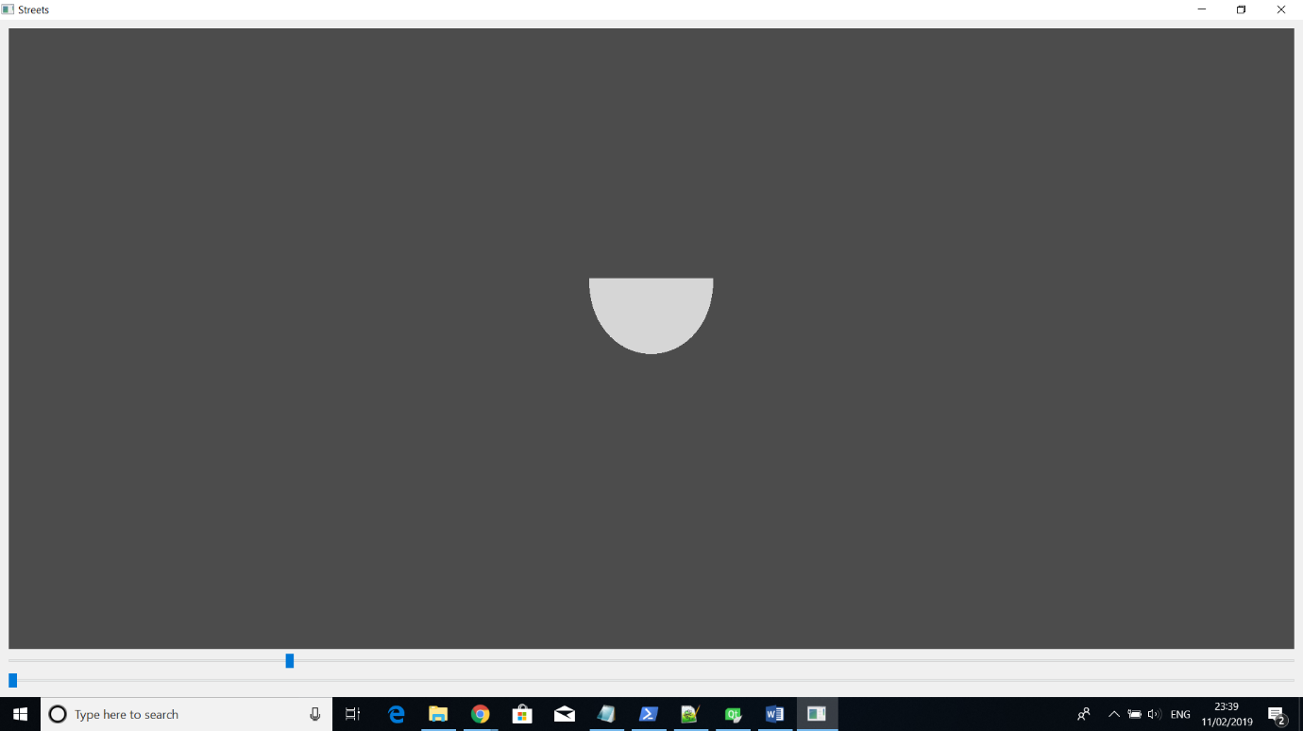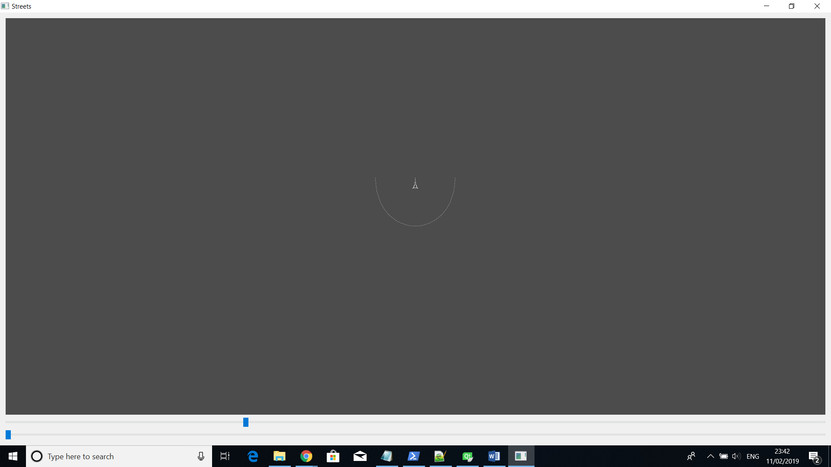

Tessellation can be performed using triangle strip method where each point from the first line together with each point from the second get consecutively passed as a vertex value and at the end the vertices are used to form multiple triangles (Picture ?).

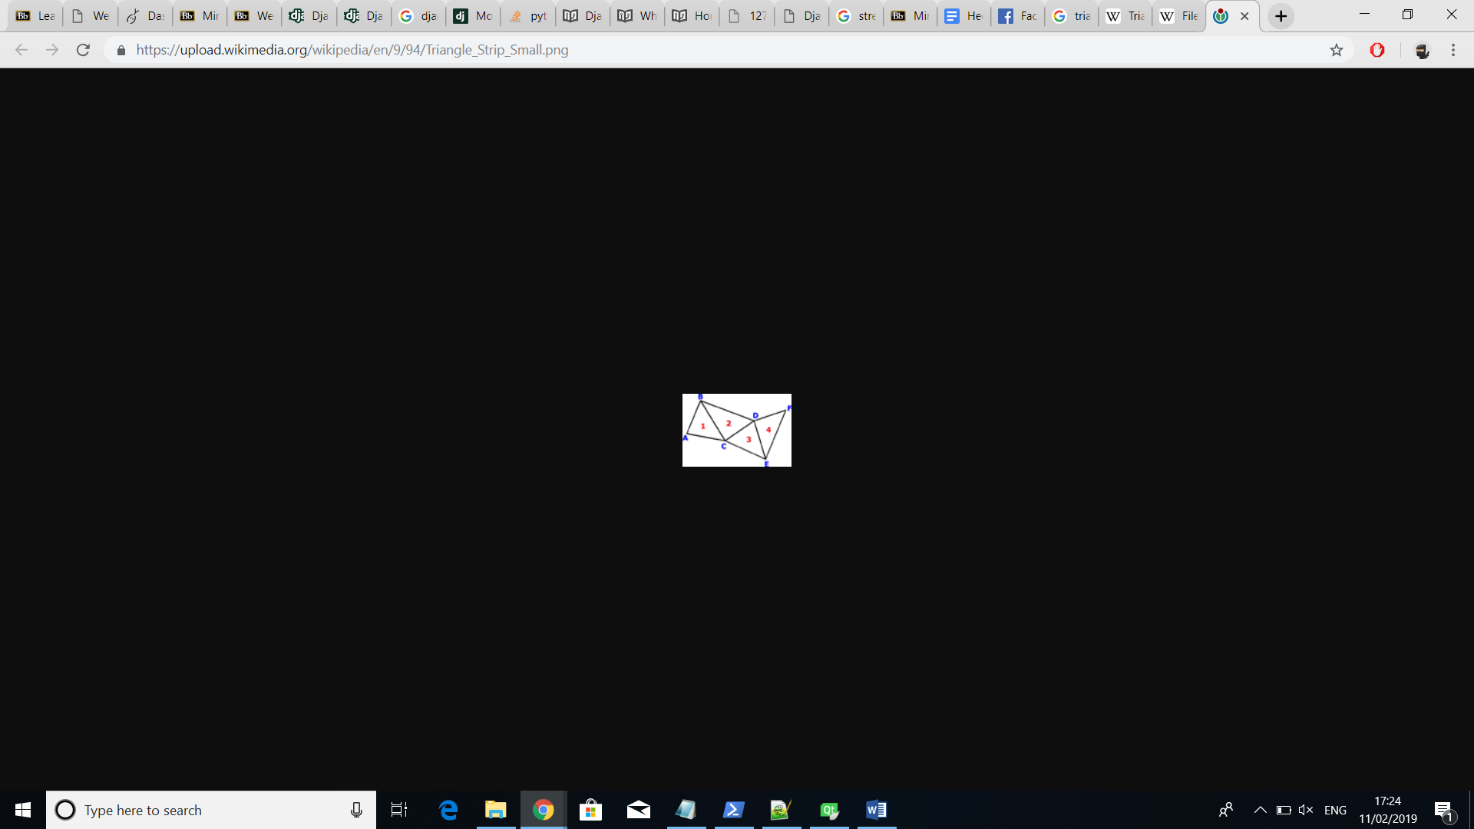

Four points can define a cubic Bezier curve – P0, P1, P2, P3. The curve starts at P0 and ends at P3. The other two points provide directional information and they don’t get intersected by the curve. The distance between them (P1 and P2) also determine “how far” and “how fast” the curve moves towards P1 before turning towards P2*

After defining a street network in the form of a graph consisting of nodes and edges, each edge can act as the axis of an individual street segment. Those segments can have different width depending on the street type. However, offsetting the edge axis on both sides to resemble a street requires the finding of offset directions and length.

However, the focus is clearly to reconstruct road and not streets. Streets are much more complex objects than roads, as they express the complexity of a city, and contains urban objects, places, temporary structures(like a marketplace). [junctions]

The aim may also be to create a road network as the base layout of a city. Indeed, stemming from the seminal work of Parish and Muller (2001), a whole family of methods ﬁrst creates a road network procedurally, then creates parcels and extrudes these to create a virtual city. These methods are very powerful and expressive, but they may be difﬁcult to control (that is, to adapt the method to get the desired result). [junctions]

Real life streets are extremely complex and diverse; we do not aim at modelling all the possible streets in all their subtleties, but rather aim at modelling typical streets with a reasonable number of parameters.[junctions]

## 2.3 Junctions

A junction is where roads meet and since our input data would have such occurrences, they need to be considered. Although not depicted on the geographic maps, in reality, those meeting points support the vehicles transitioning from one road to another using a curvilinear connection (*Picture ?*). Such curves, however, are not provided to all pair of streets but only to neighbouring ones in order to prevent crossings. This chapter would, therefore, discuss the algorithmic steps used to achieve the smooth transitioning between roads in the form of junction objects.

Before attempting to approximate the objects, a prerequisite step of turning the inputted street data into street segments is required (Section 2.2). When that is covered, the algorithm’s first step is to find the closest offset lines between each neighbouring street segment pairs. Those lines would serve as a basis for constructing the curves. (Section 2.2.1) explained the different curve structures where control points guided the curvature between a given start and end points.

In our case, the simplest solution would be to use a quadratic representation with one control point which can be defined as the intersection point between each pair of offset lines.

What is left are the start and end points.

(picture of two maps – one without curve and one with from satellite)

5. Pick the closest inter. point for each street segment and cut the street before that line by a certain amount

6. Use the points where the street is cut a starting or ending points for constructing the curve

7. Make into segment

In the implementation I can say:

1. The intersecting line pairs are found using the algorithm for finding building parcels

2. How the intersection points are stored and how the closest intersection points are stored

3. How OpenGL handles the tessellation of the junction object

(The whole plan doesn’t sound right)

About the curves, I might not mention the difference here but in the implementation I can say that the curve is divided into many lines. Therefore, we check the intersection of each small line.

(Another problem is the pictures below. If I put them here and I don’t explain about the curve, I shouldn’t put the pictures about the curves. Then, I will need to put the pictures about the curve in the implementation and it will look strange)

(Also, I can explain the other way of finding the turning radius for the junctions (using the circles). If I explain it, then I need to divide the section into ways of finding the turning radius and ways of making the whole junction a segment)

needs smooth transitioning

turning radius is curved

each node is a junction (where the edges/streets join)

explanation of how the pairs were found -> using the finding of loops

how the curve was found??

how the segment was found/traced

how the streets were cut -> considering the t

where the junctions were stored

### 2.3.1 Computation of arcs

discuss the two cases of curves?

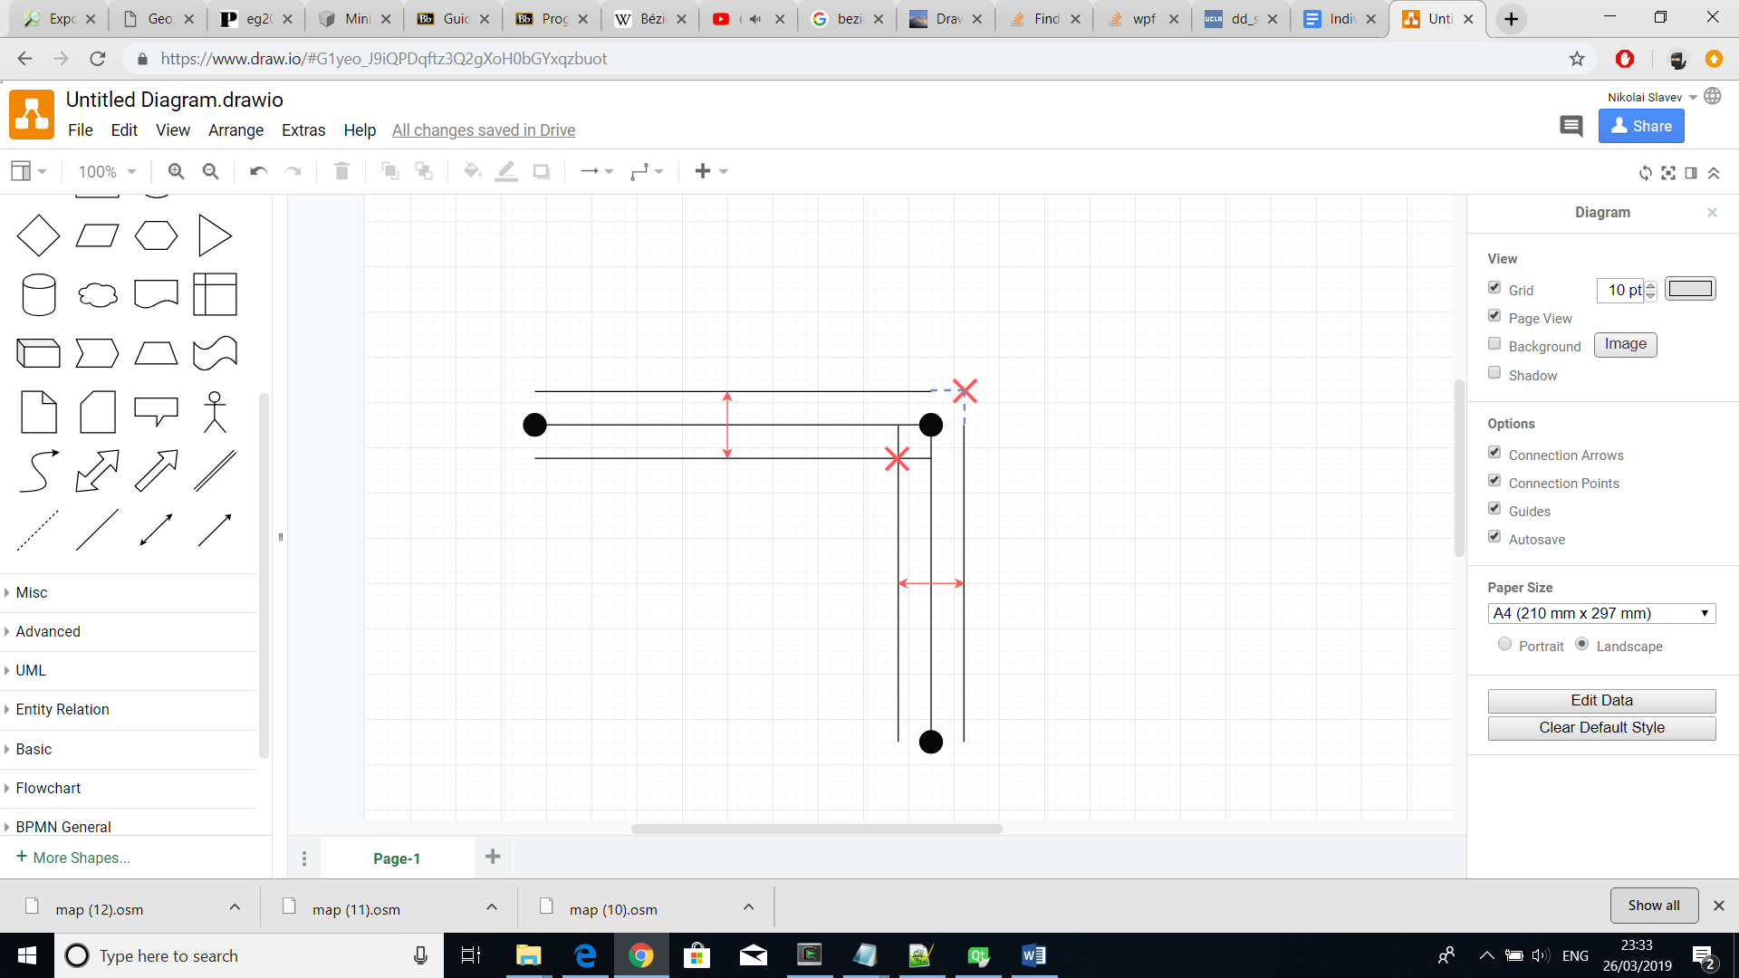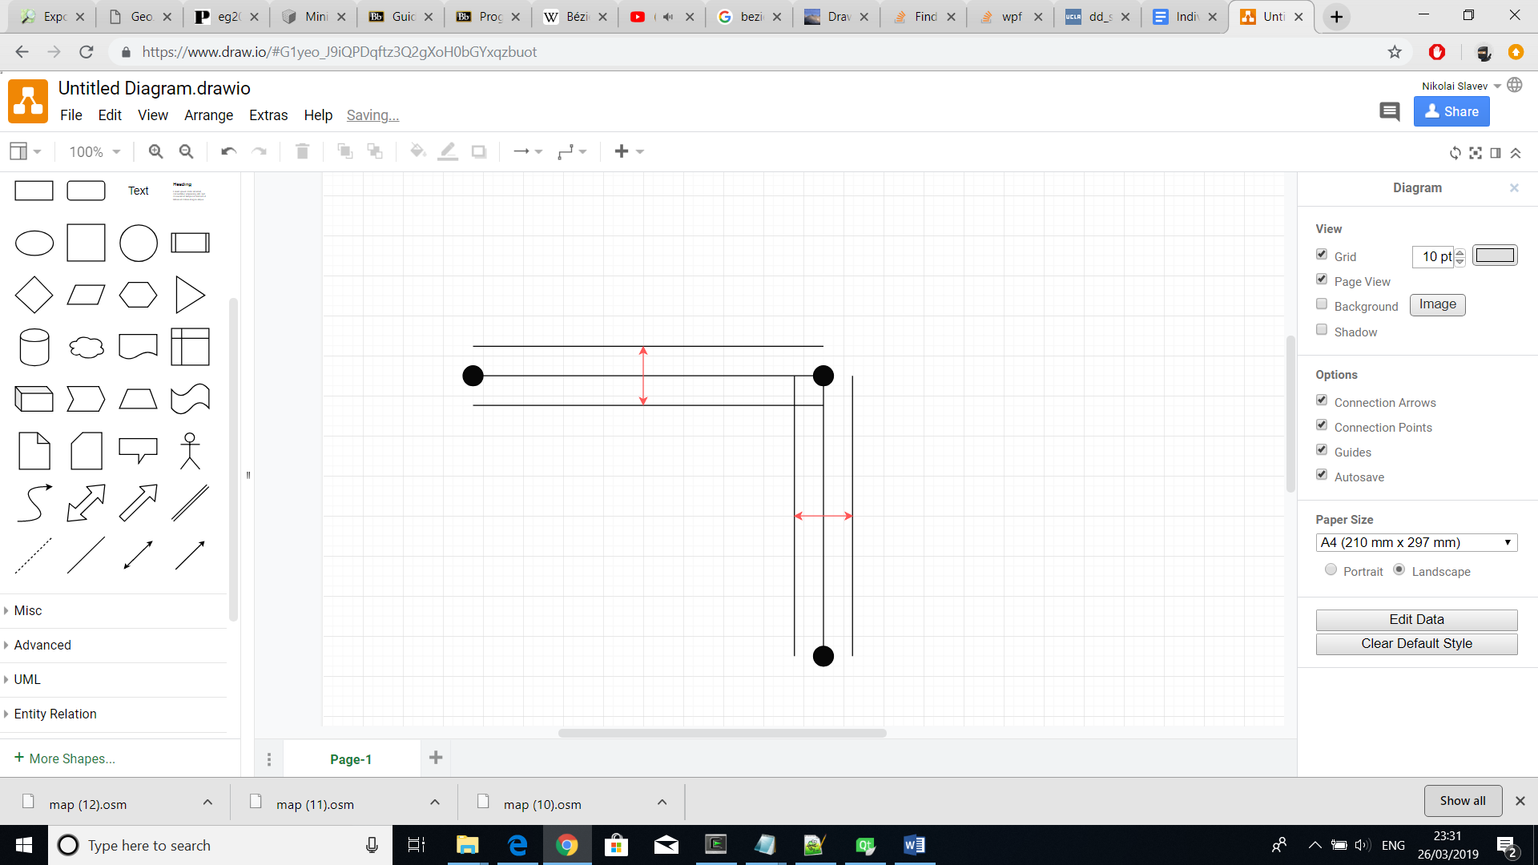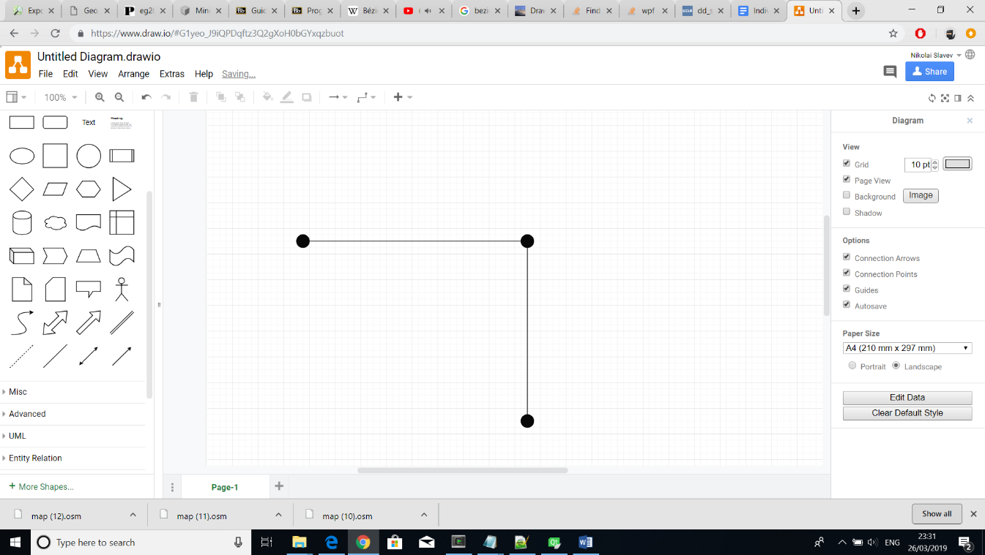

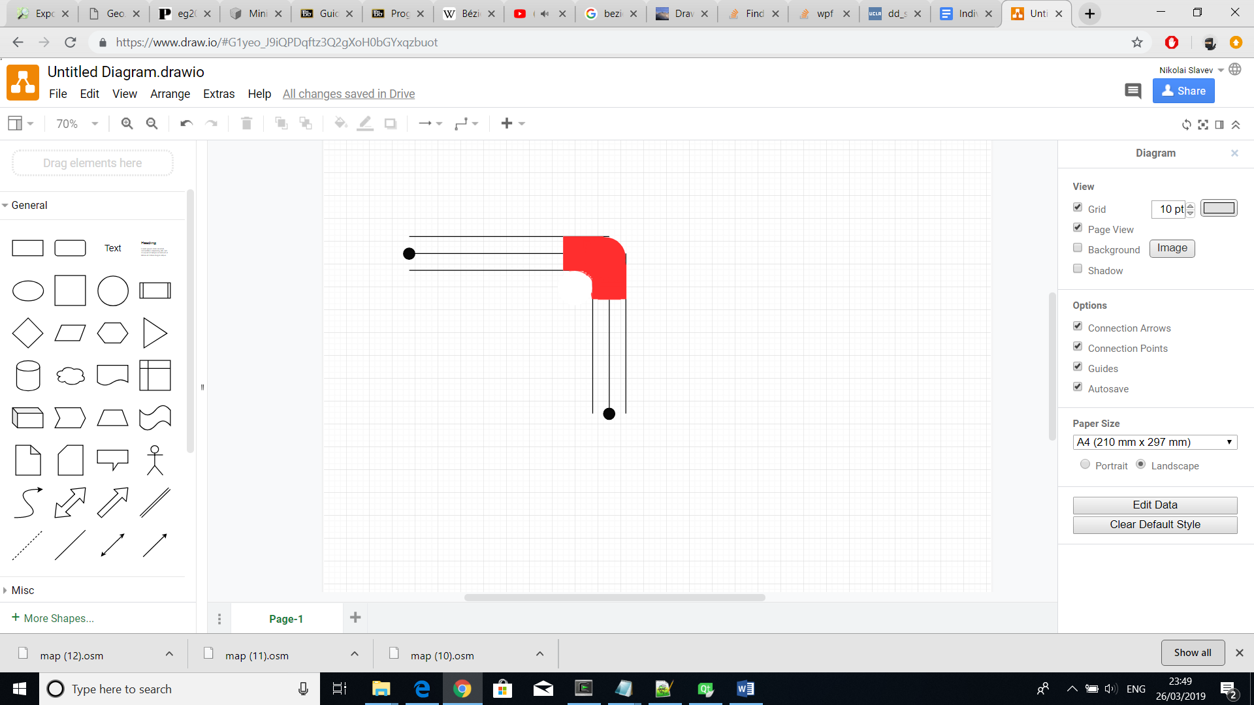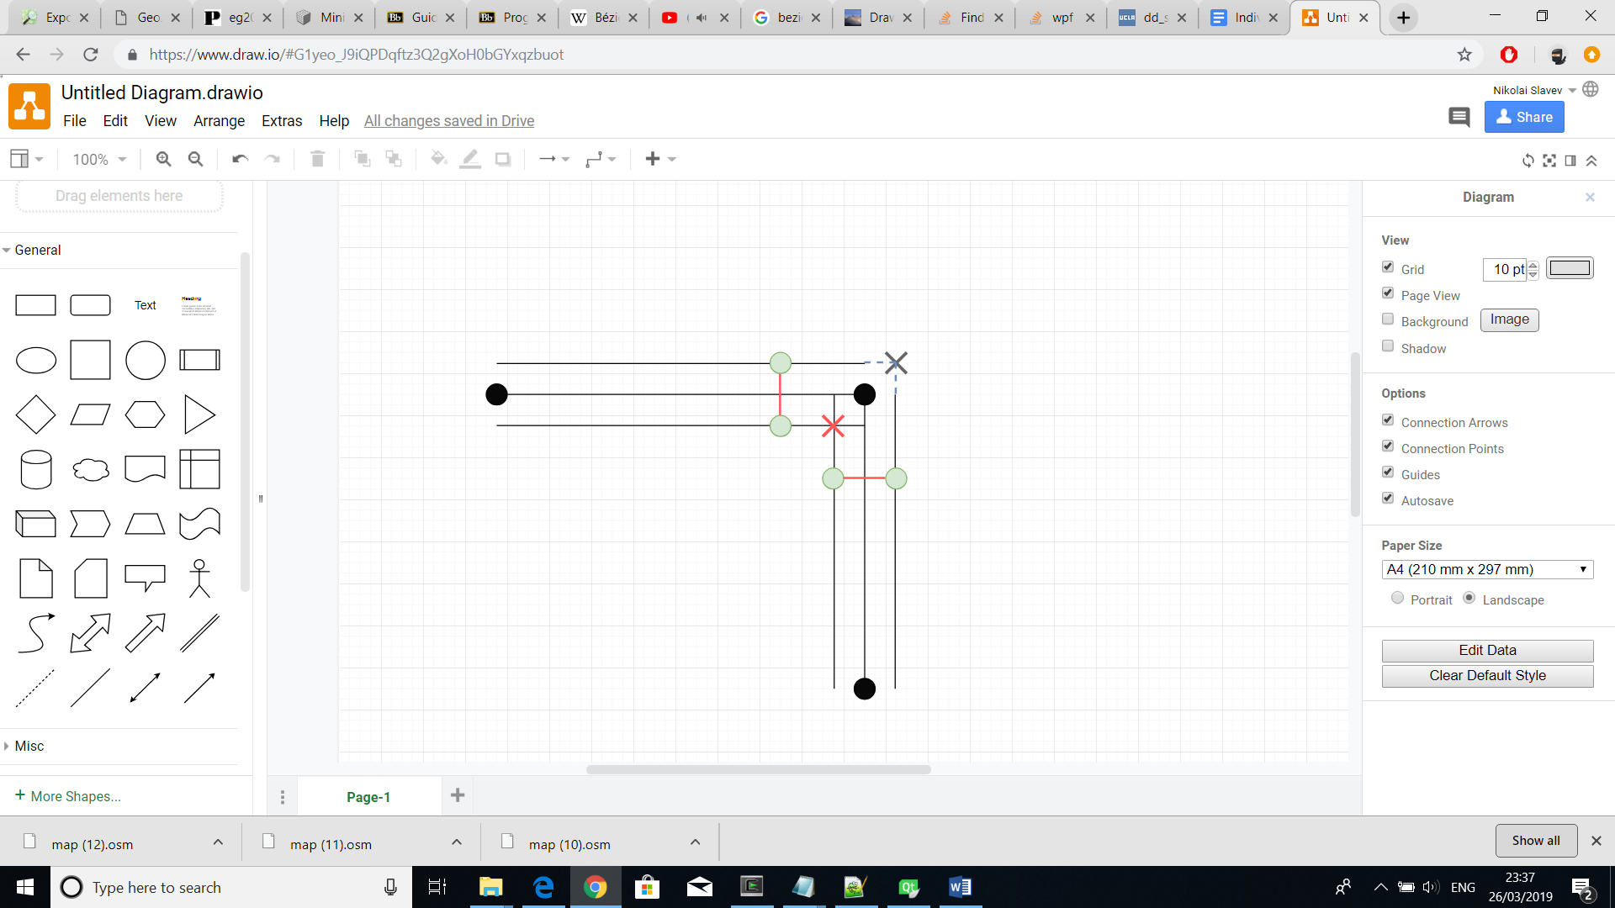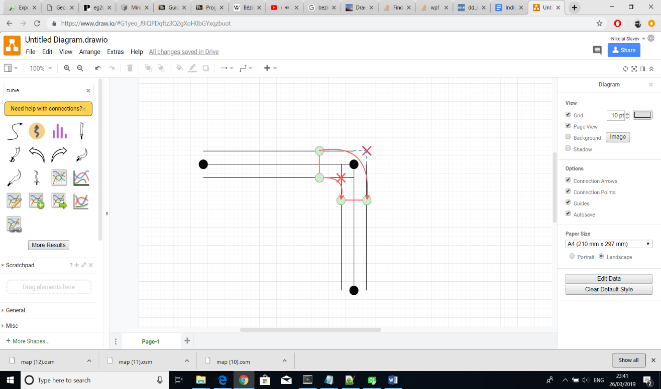

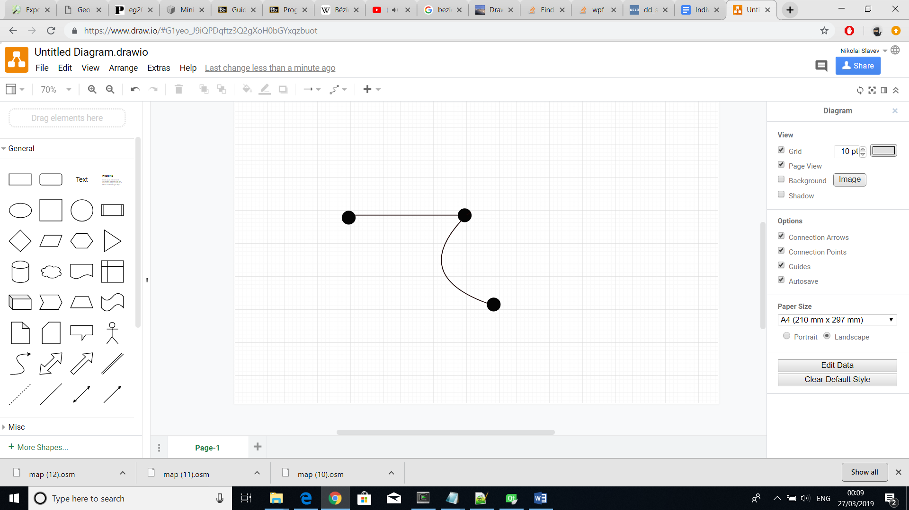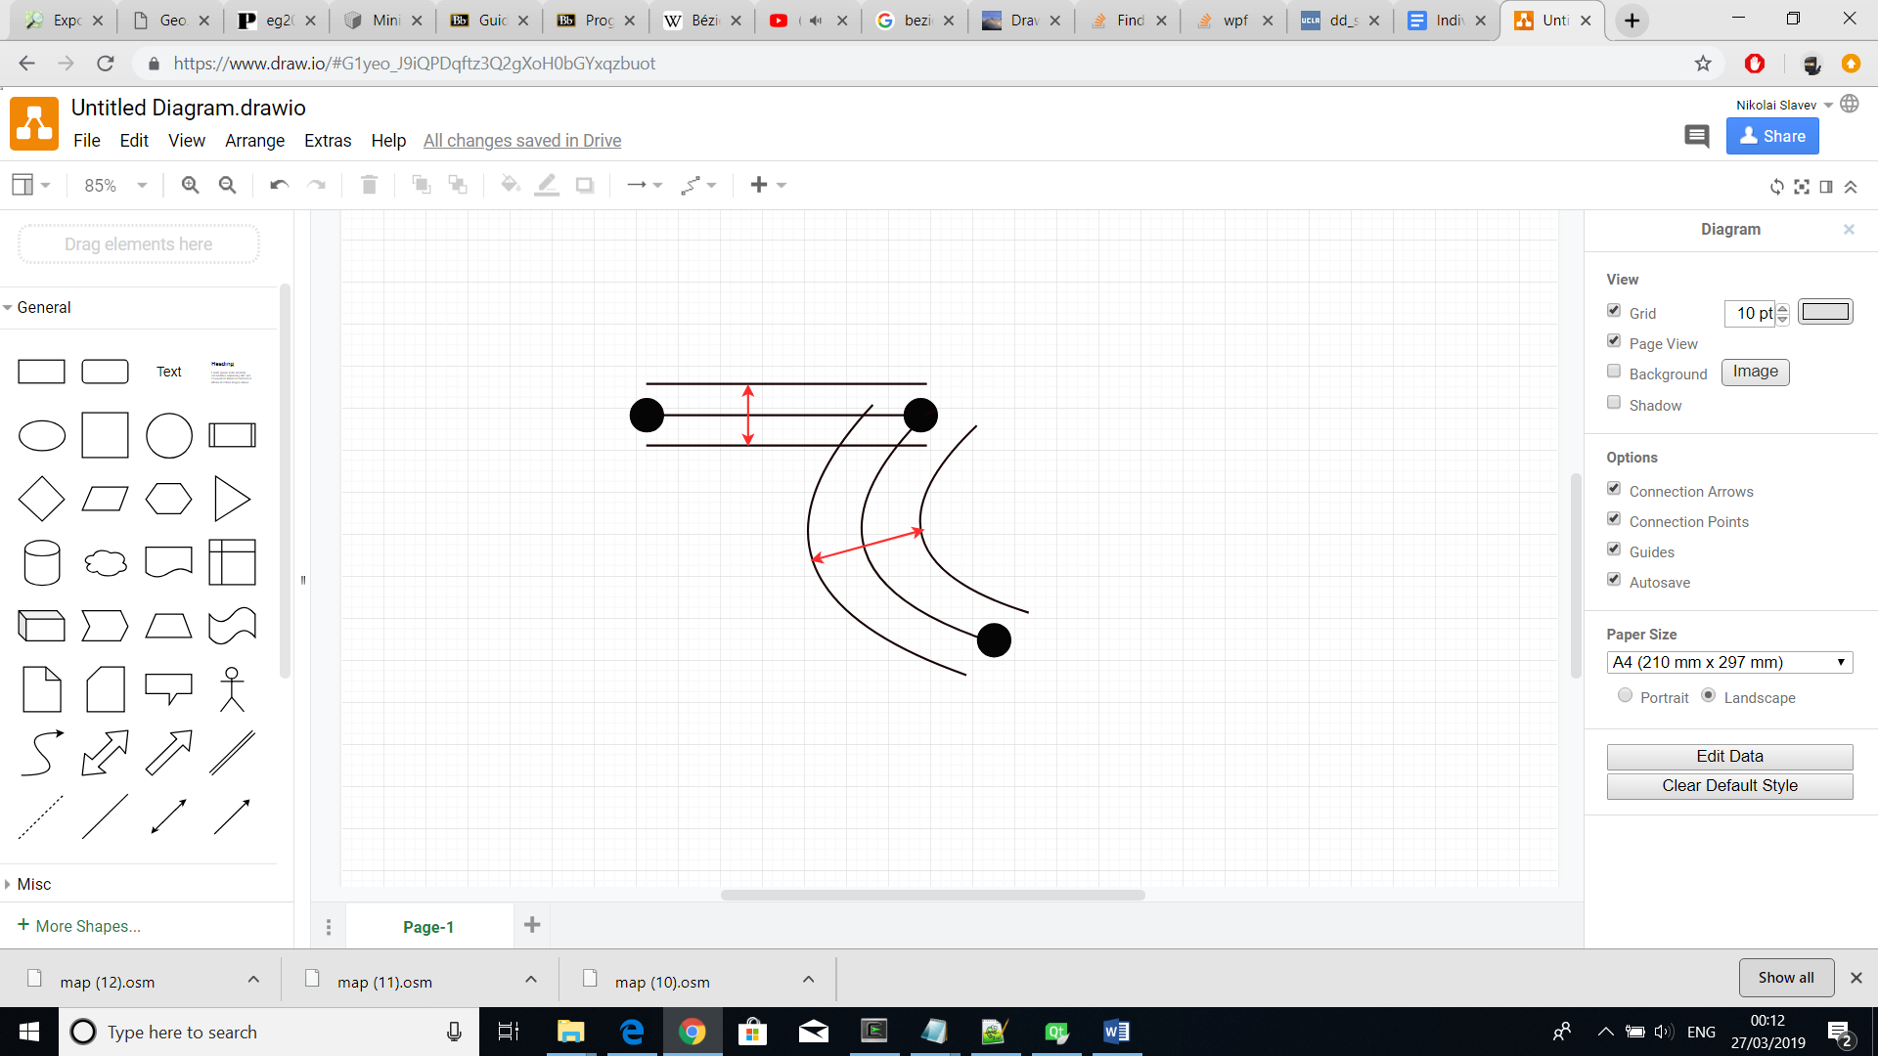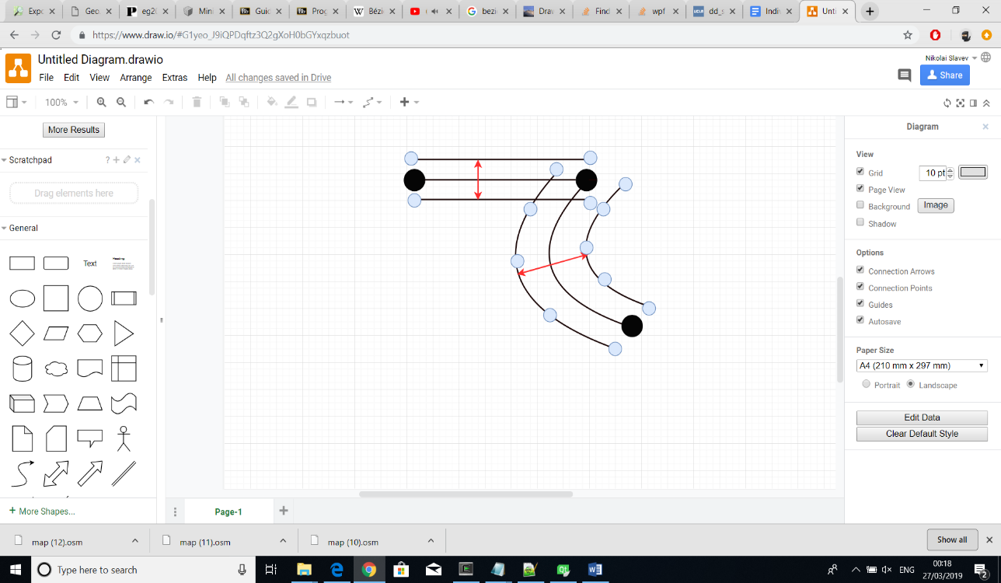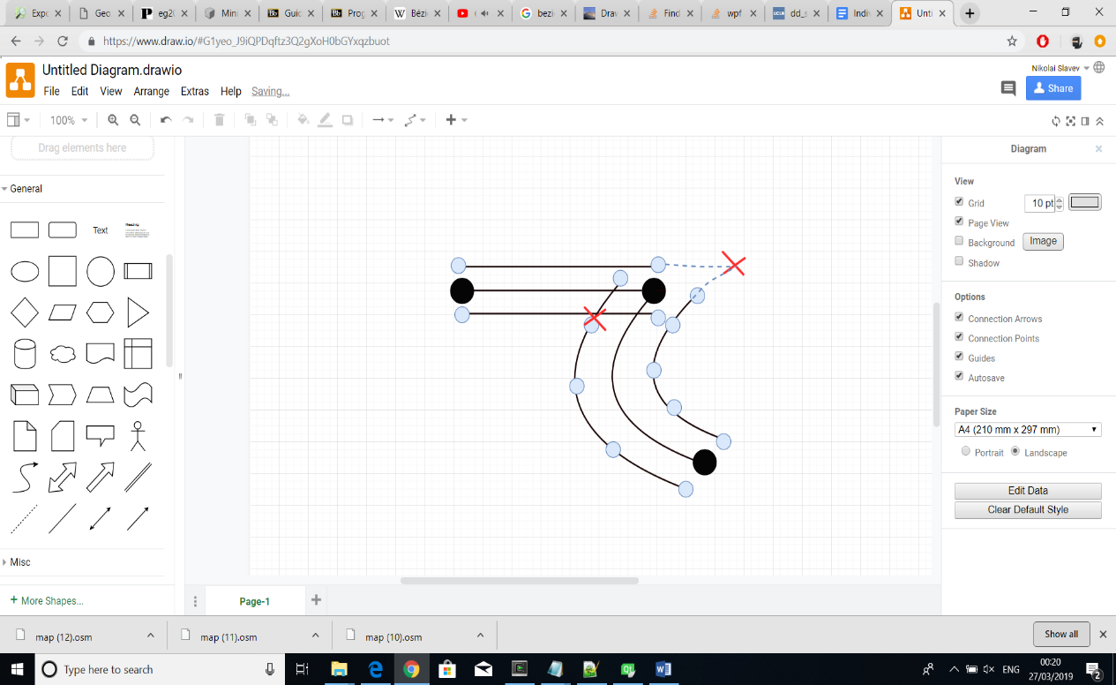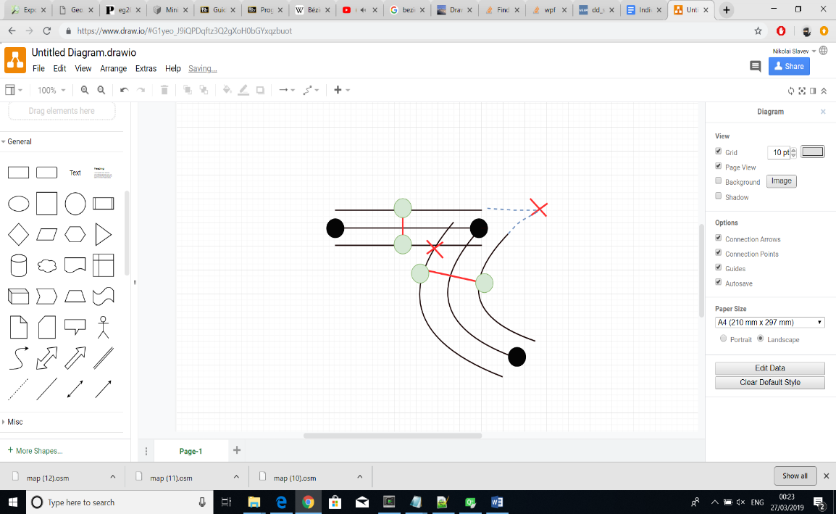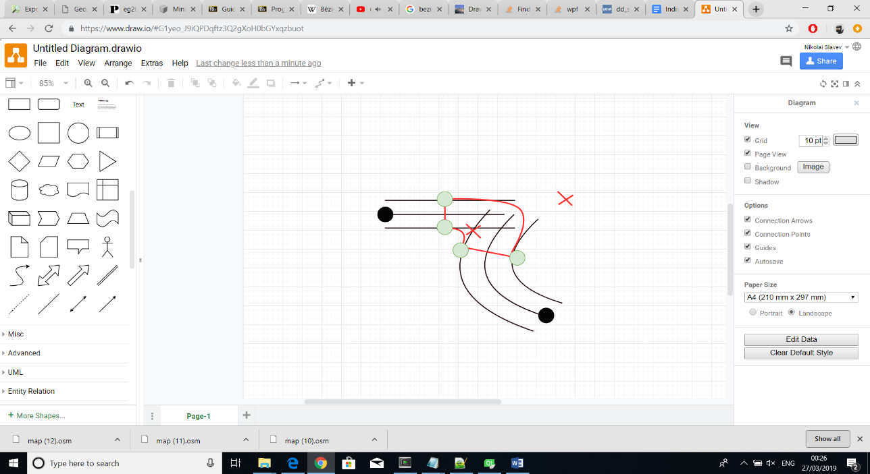

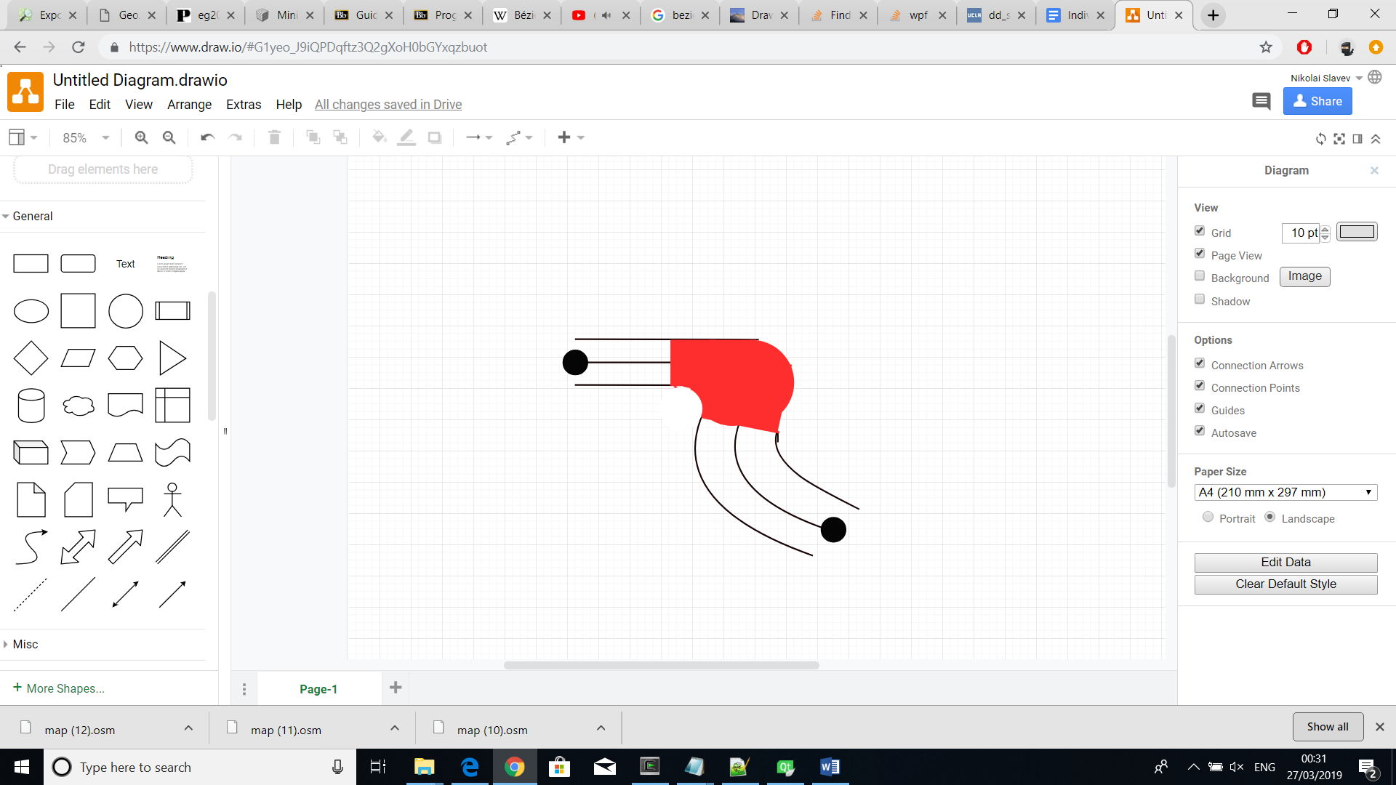

### 2.3.2 Computation of surfaces from arcs

say that the streets are cut

## 2.4 Building Parcels

### 2.4.1 Finding parcels

After generating a street layout with a graph network structure, inhabitant areas with multiple buildings can be allocated. Such areas are naturally placed where they can be fully surrounded by streets because each building would need a direct street access. Finding building areas can, therefore, be interpreted as a problem of finding loops in a graph network.

A very efficient solution is a graph traversing algorithm applied on a bi-directional graph. It repeats a sequence of steps to find all loops which do not contain others within them and would also return a single loop that covers the outer boundaries of the graph network.

The algorithm starts by finding a vector, labelled as S, of two neighbouring nodes from any of the graph’s corners. Then, other vectors, labelled as E, are constructed by using the ending node of vector S and each of that node’s neighbouring nodes. At the end, the angles between S and each E are computed. All next iterations follow the same steps except that vector S would now be the vector E that formed the smallest angle. In other words, the traversing algorithm would choose the next counter-clockwise edge each turn. The only constraint is that an edge cannot be taken in the same direction twice. A loop is found when the path meets its starting point. That point would remain the same unless there are no more edges to take. If that happens, a starting point would be the node that was previously visited.

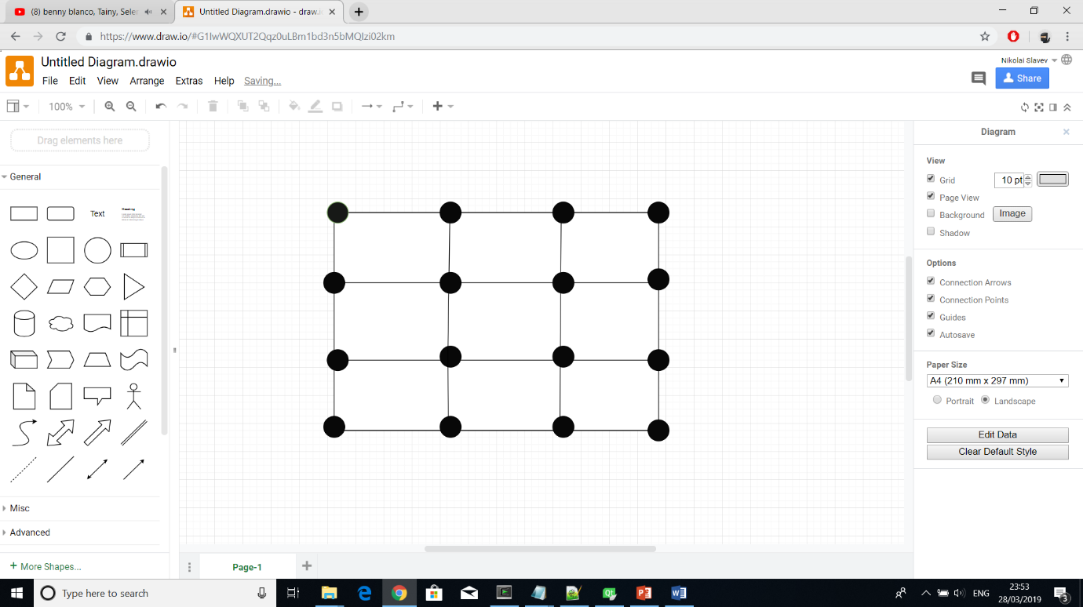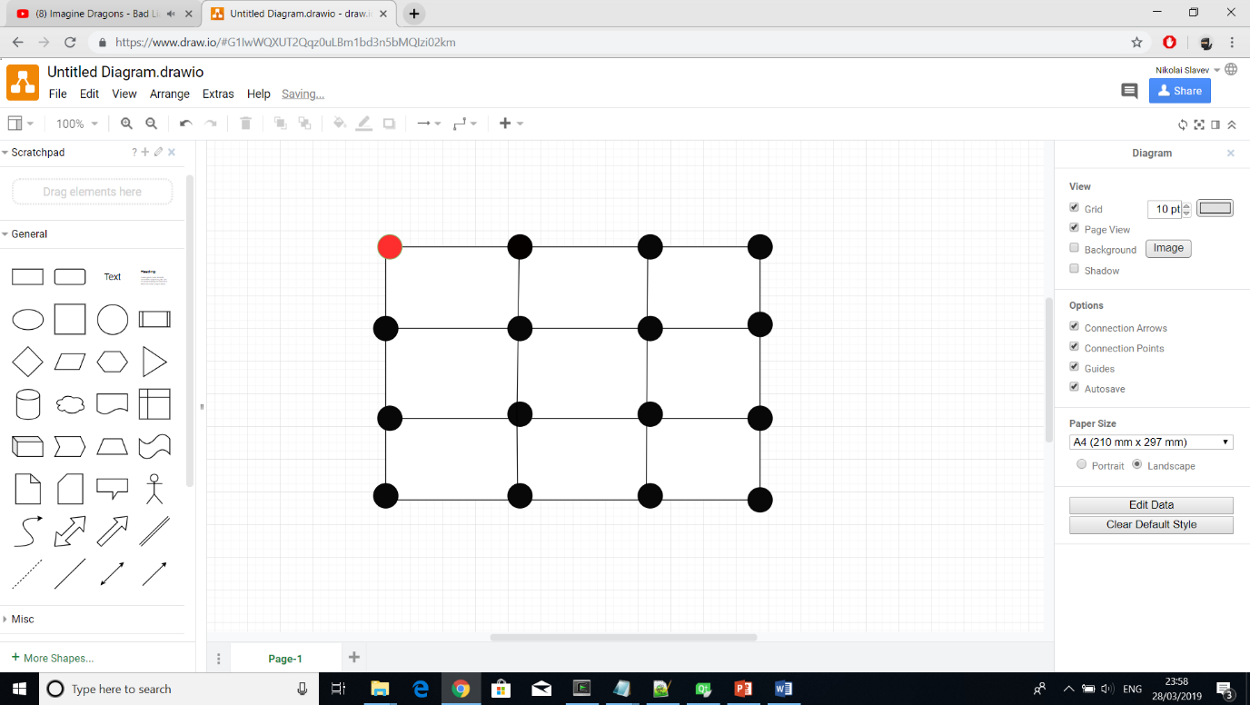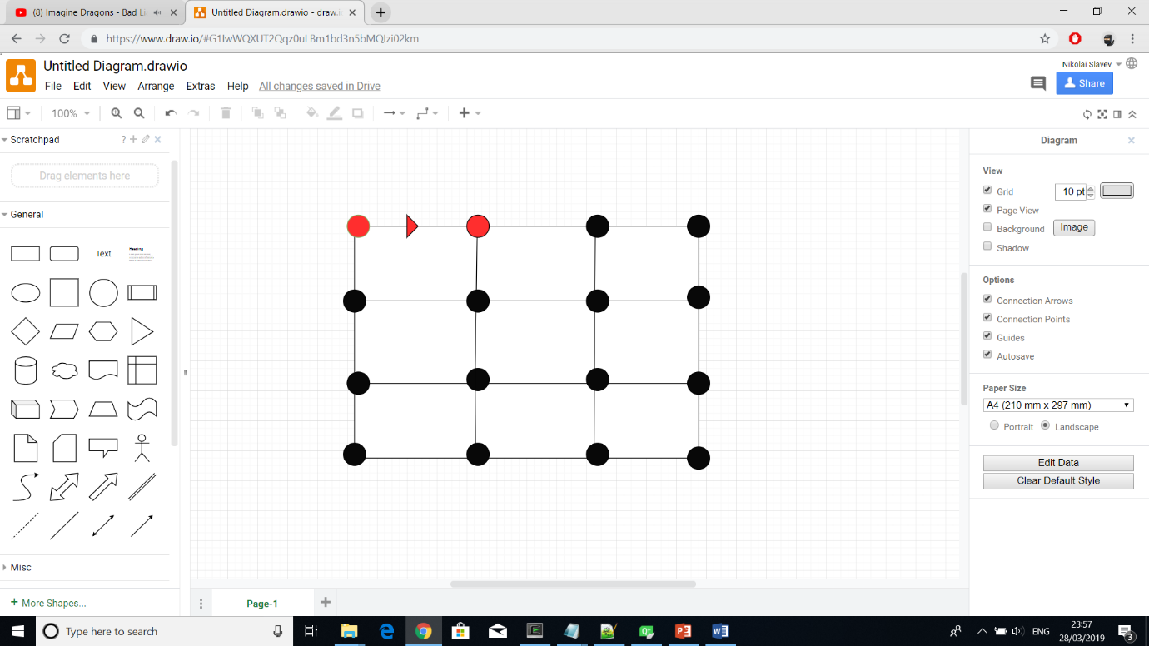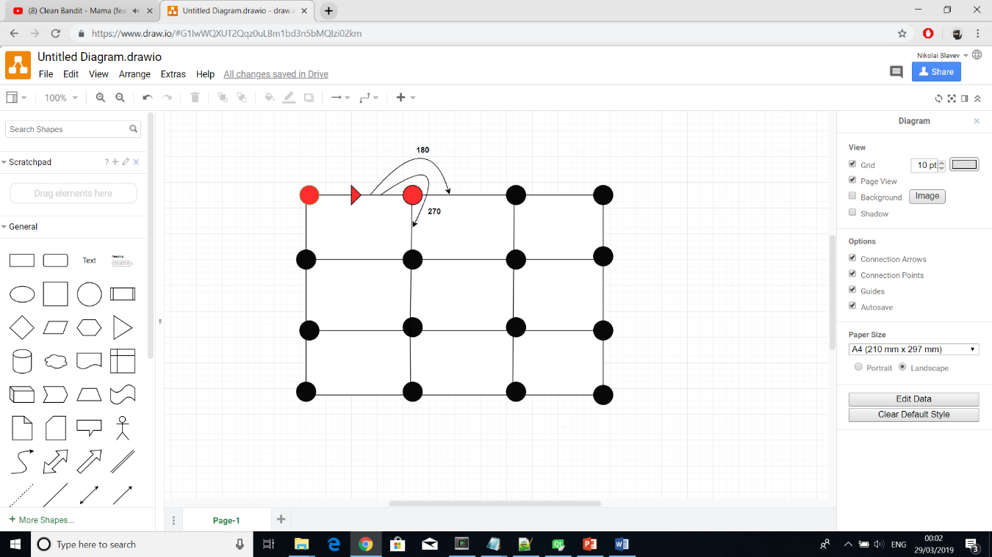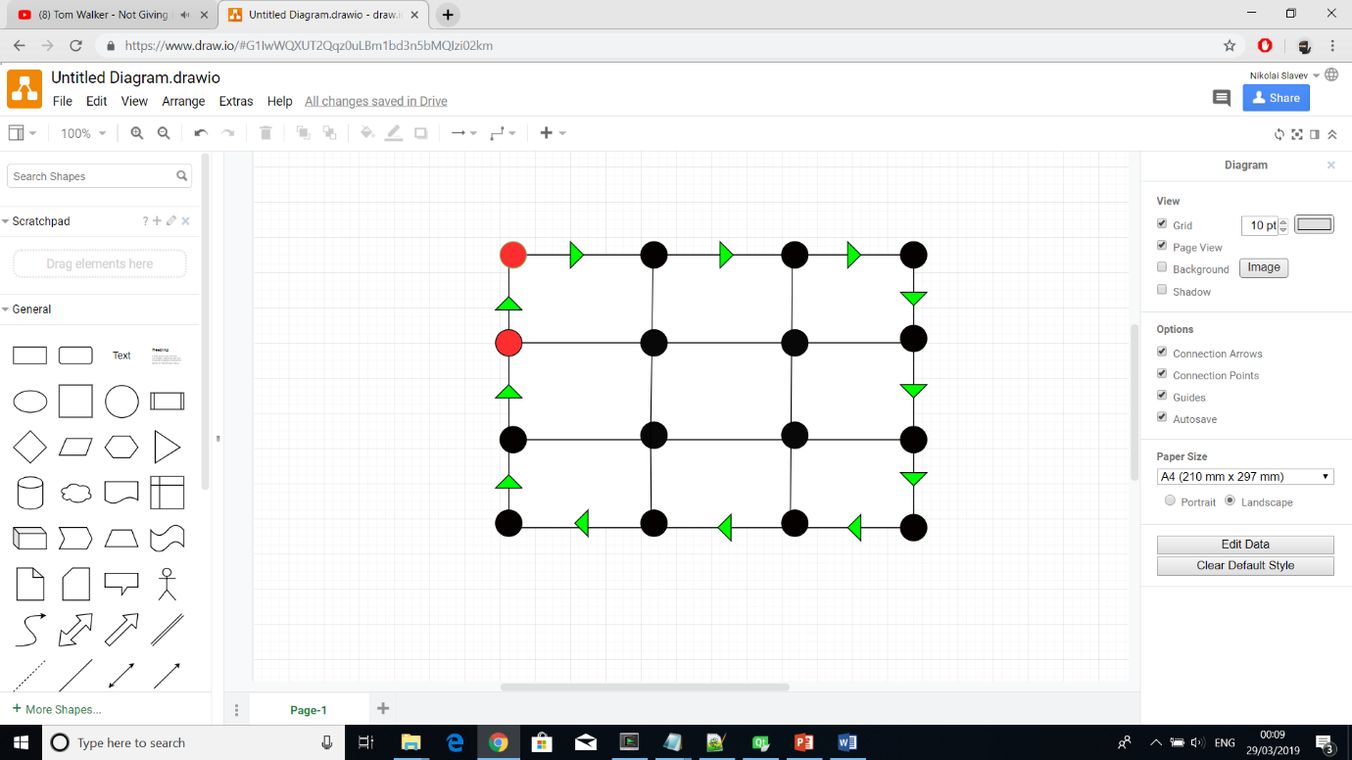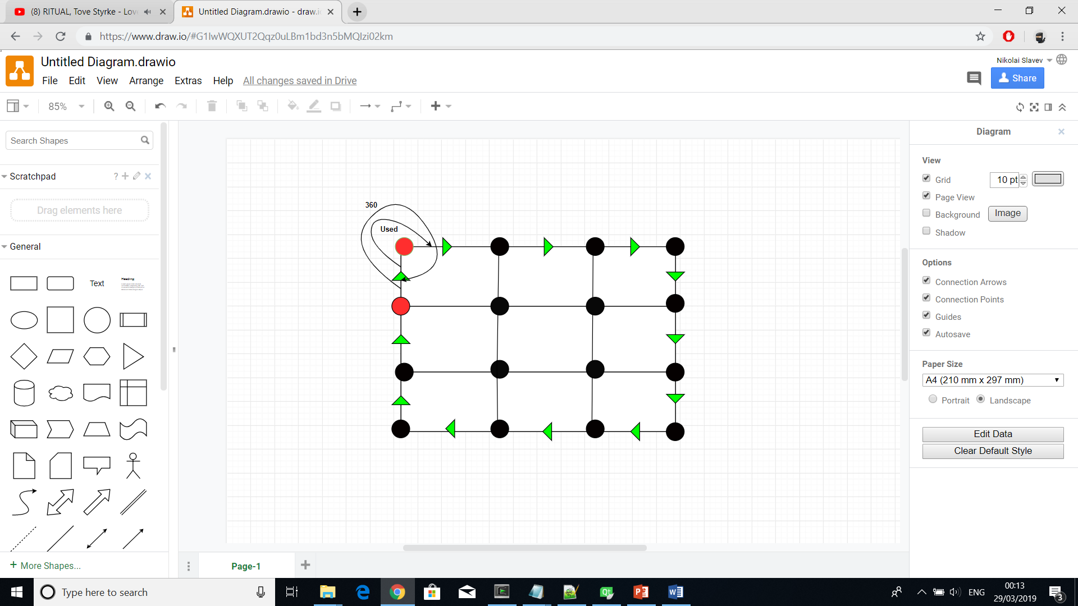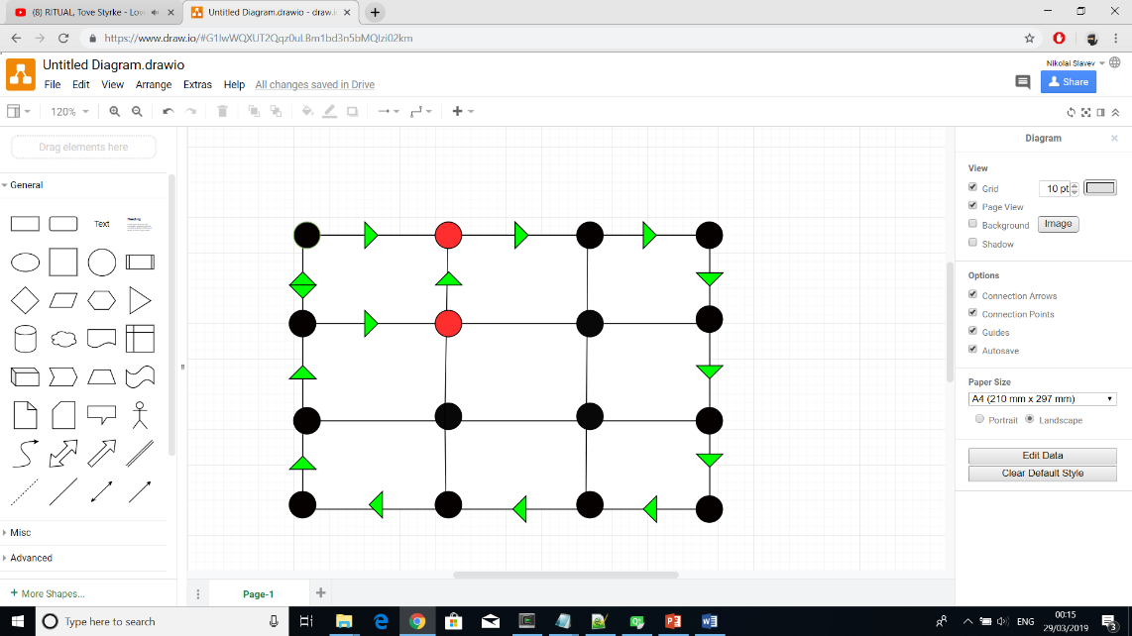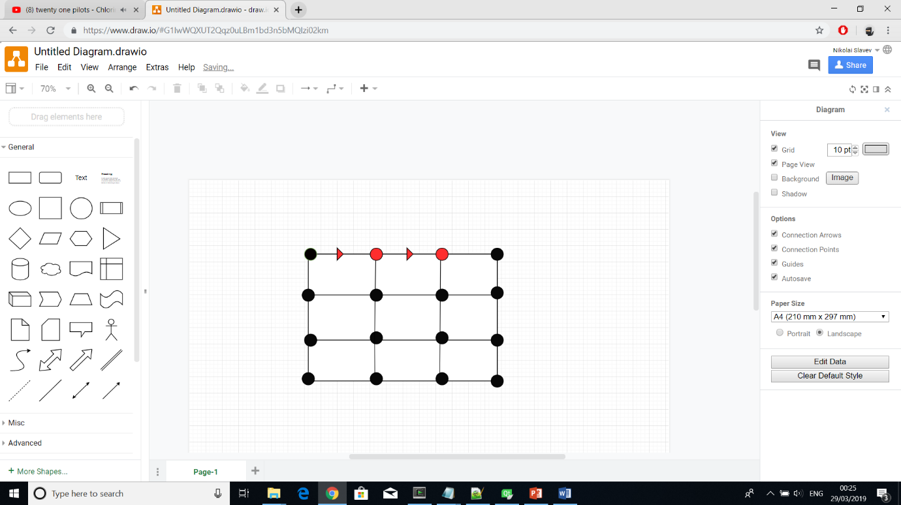

### 2.4.2 Subdividing parcels

Finding the shape and location of random buildings within an area can be accomplished through a subdivision technique. A suitable algorithm for doing that recursively divides an object into smaller pieces until they reach a certain threshold size limit. Before being able to find the division line, however, a minimal bounding box is required. That requirement accepts only convex objects but since the project considers curved streets, concave shapes are possible. Therefore, an additional method called convex hull is used to find the convex representation of a concave object. After ensuring object convexity, the search for a minimal bounding box undergoes several iterations. Each iteration picks an object’s edge and finds a bounding box such that one of the box’s sides overlap that edge. Then, the bounding box with least area size is assigned as minimal. The division is performed by splitting the minimal bounding box in half based on its longest edge. Using that division line, the initial concave object splits itself accordingly and, as a result, smaller objects are returned ready to be used as inputs for the next recursive iteration.

Steps:

1/ Retrieve a building parcel (it is usually a concave object)

2/ Find the convex hull of the object (resulting in a convex object)

3/ Find the minimal bounding box of the convex object

4/ Pick the larger side of the rectangle and divide the box at the middle of that side.

5/ Iterate over the same steps until the area of the objects is below a given threshold

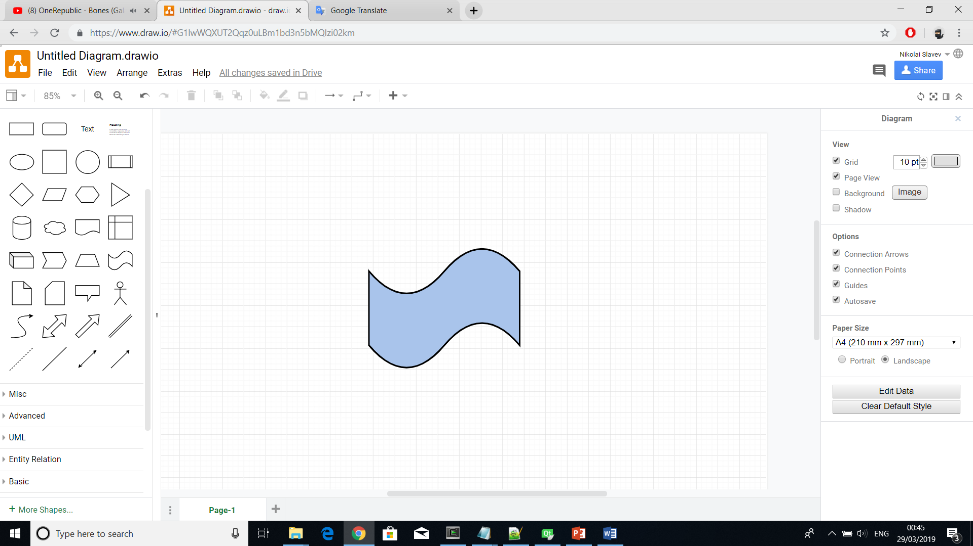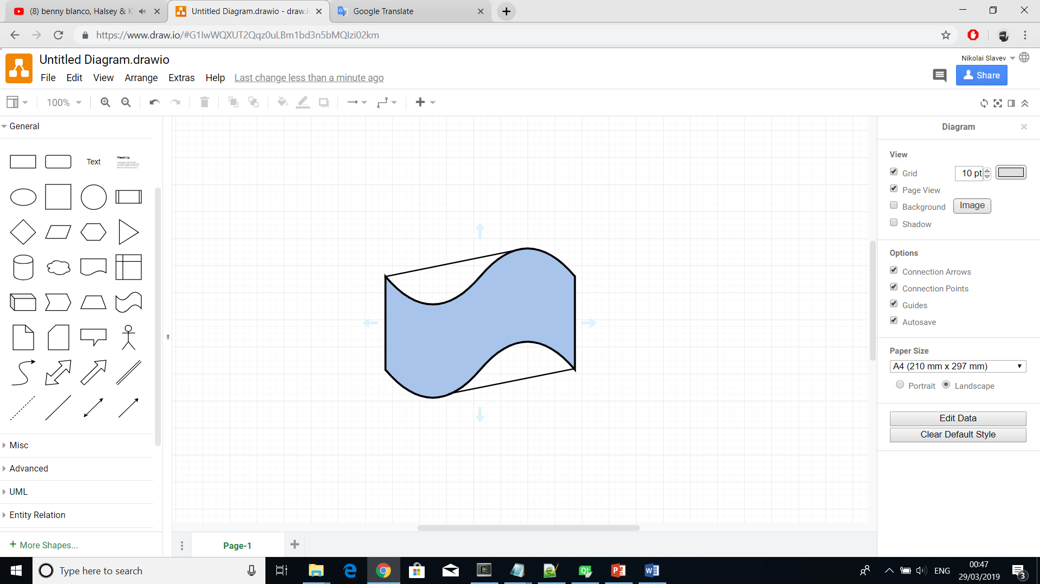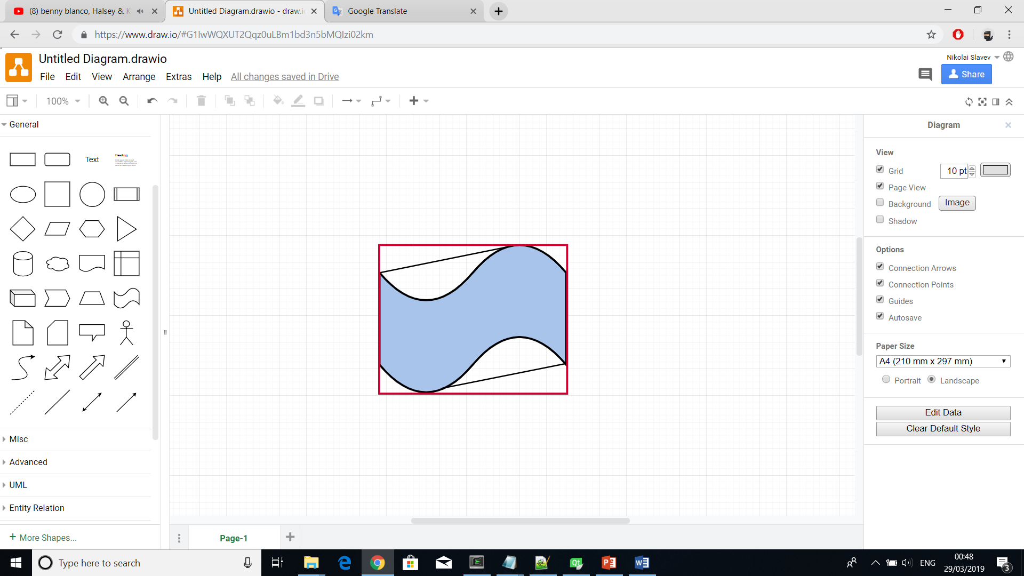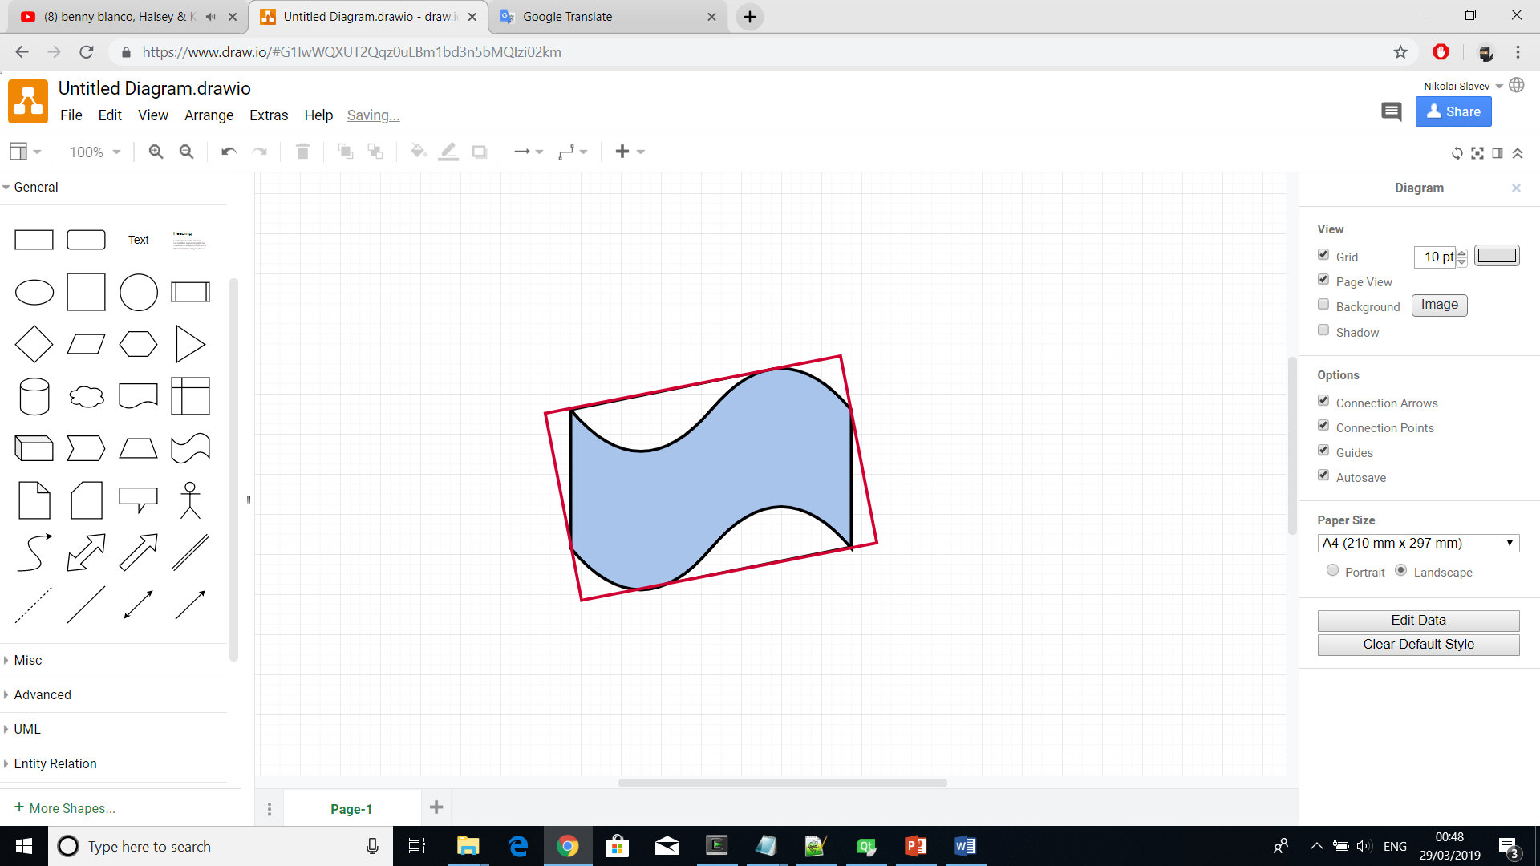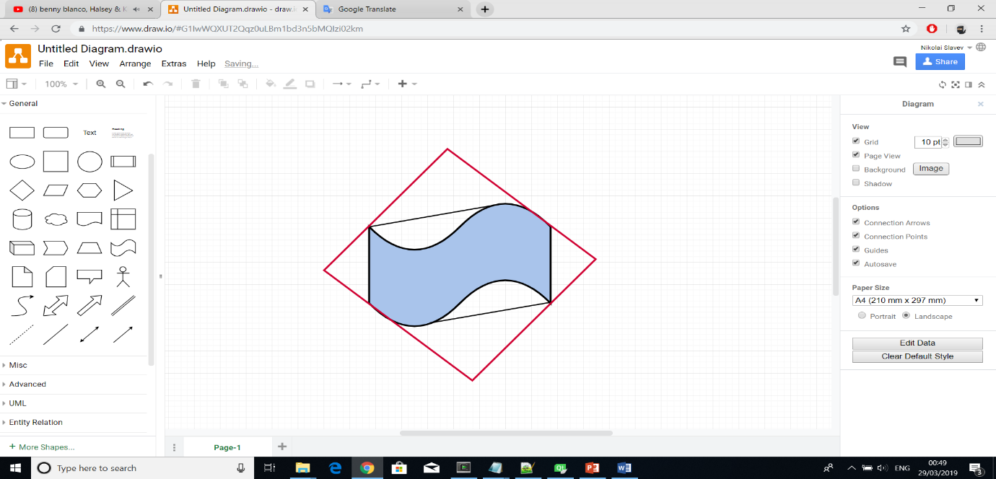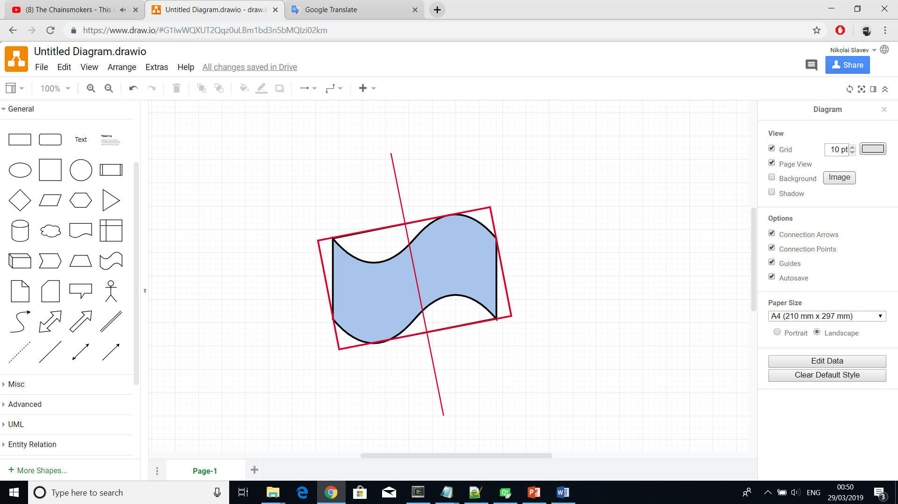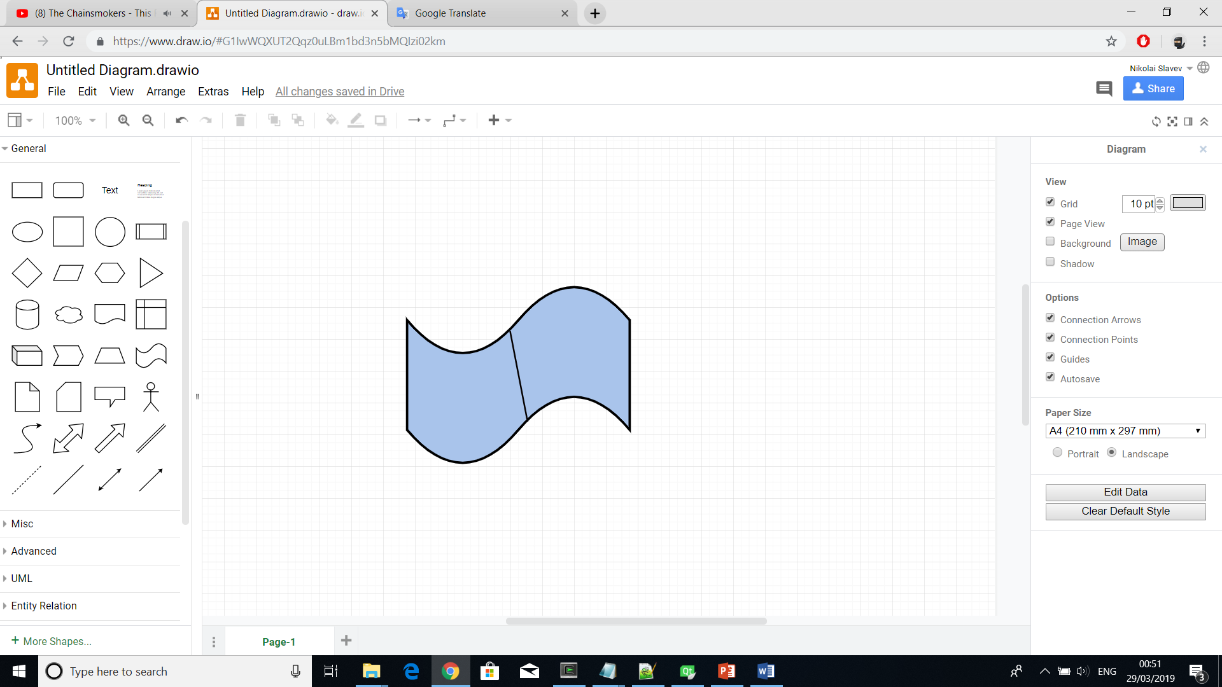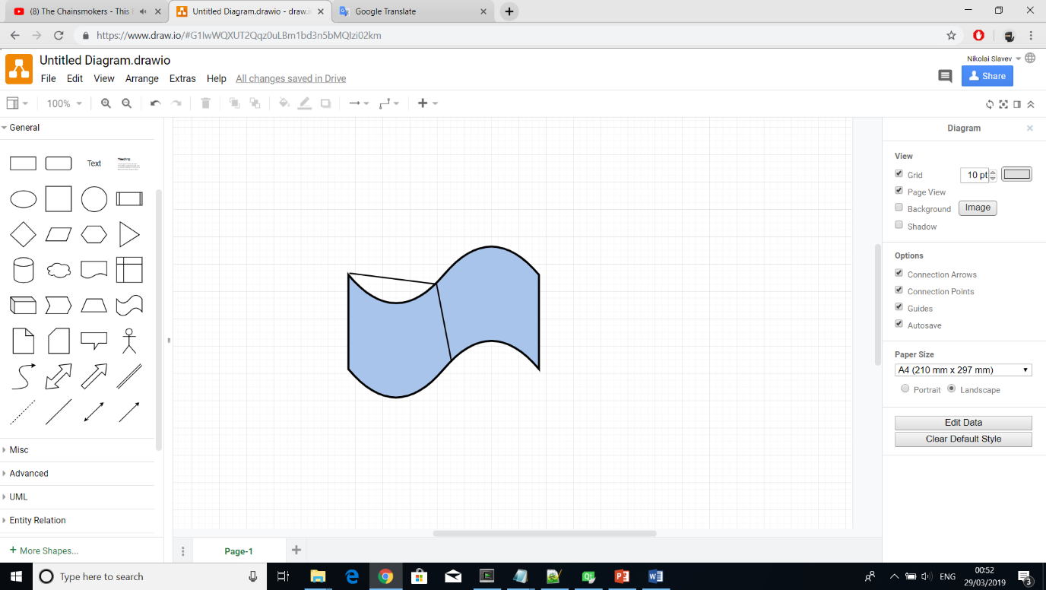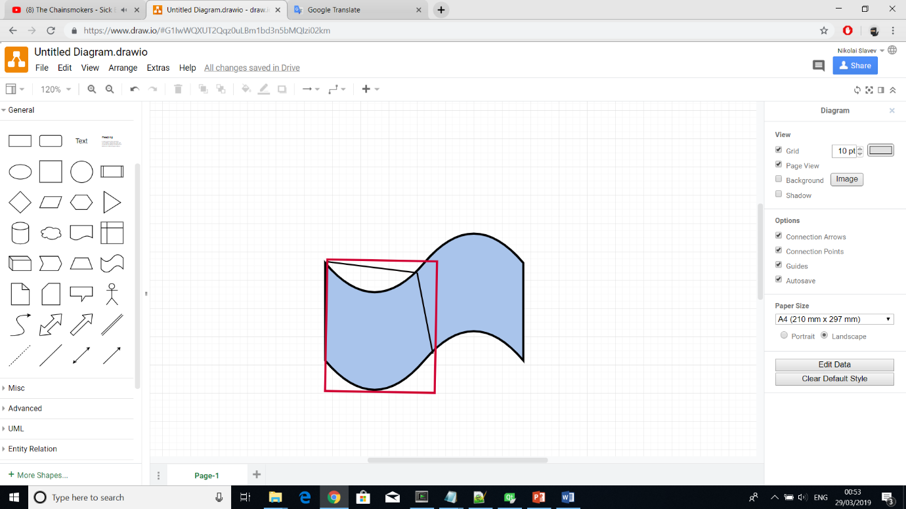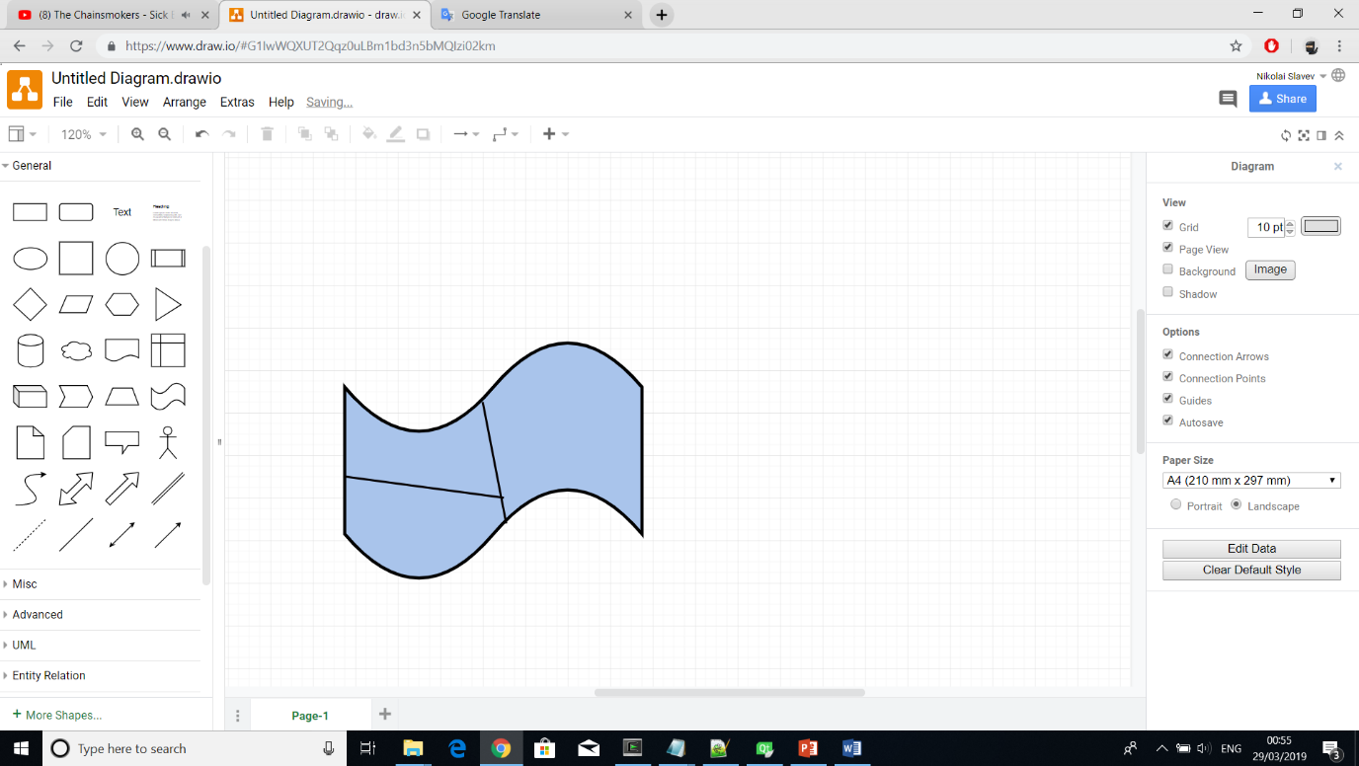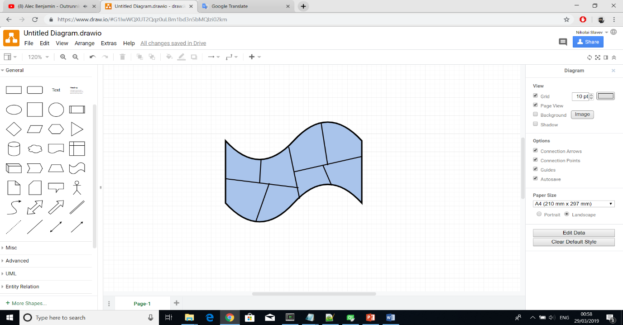

### 2.4.3 Buildings

briefly say what we do -> not sure if it is necessary

For every allocated space a building can be generated. These buildings are again procedurally generated but follow a different L-system parametric approach which can only apply to a single building type. Therefore, for every type, whether skyscraper, commercial or residential, a different set of production rules are applied.

To allow for an automatic level-of-detail model creation, a restricted ‘decreasing apices’ L-system class as described in [14] can be used. Since the generation of the building starts with its bounding box as the axiom, the output of each iteration can be interpreted as a refining step of the geometry. The output of the L-system is fed to another parser, which translates the resulting string into geometry readable by the visualization systems.

## 2.5 Algorithms evaluation and decision

GIS for input because it supports well scalability, realism, and ?

The most recent paper to be evaluated although the aim was to accurately construct the streets considering width and turning radius

linear, quadratic and cubic Bezier curves

linear will be used for most cases

quadratic can be used for the turning radius because it’s easier to find one control point than two

cubic will be used for normal curved streets because it is a necessary step in case B-Spline will be implemented. Also, I have noticed that the GIS data implements a simple curve using at least 3 polylines which means that the curve will be made of 4 points (start, end and 2 control points).

the turning radius will be calculated using curves and not circles because curves will be already adapted for use on the software and using the circle solution would delay any additional developments due to the time restriction. Also, circles don’t add much benefit over curves.

finding the large building parcels ?

dividing the large building parcels into smaller lots can be made using the division of the minimum bounding boxes because ? no idea

# Chapter 3 Project Methodology and Planning

# Chapter 4 Implementation

This chapter will give thorough explanation of the design and development approaches. It will, firstly, discuss the technologies, user interface and code architecture before moving to explanations of how the project’s objectives were met.

## 4.1 Technologies Used

The software was written in C++ using Qt Creator as an IDE and OpenGL as a graphics rendering API. Other supporting technologies were OpenStreetMap, ReadOSM and SketchFab.

The decision to use C++ in conjunction with Qt Creator and OpenGL was primarily influenced by the Computer Graphics module as it substantially covered the foundations of graphics development and rendering using those technologies. Compared to other alternatives, the mentioned choices have significant advantages. Using C++, for example, developers can benefit from memory management, extensive graphics libraries, large graphics literature with supporting community and diverse opportunities for computational speed improvements. QT Creator, on the other hand, facilitates the coding process providing cross-platform support that includes compiler and debugger programs - MSVC and CDB in our case. It is a popular choice by many graphics developers and has a massive community base.

In addition to the main technologies, others were required to ensure completeness of the project. Due to the decision of using geographic data as a street network input, a set of software solutions were needed to provide and parse the data. OpenStreetMap had the ? and was used for exporting selected map regions. Then, a lightweight library called ReadOSM was used to parse and structure the exported OSM file.

SketchFab – website which displays an obj file

(probably don’t need to mention sketchfab as it is not required and any other 3D editor can be used?)

## 4.2 User Interface

In the computer graphics world, visualisation is crucial as it best communicates the idea and outcome of a product. The developed software, therefore, not only emphasised on technically correct but also on visually appealing and interactive imagery. To accomplish that, the user interface included a large visualisation screen as well as possibilities for extensive camera control, scene editing and scene simplification.

A large screen was included because it is a necessity in every visualisation especially when the model displayed has the scale of a city (refer to the picture). Camera control, on the other hand, can assist the presentation by showing it from different angles. The project made use of the arrows to move user’s viewing angle forward and backward as well as rotate it left and right. QKeyEvent was used to detect keyboard press events and alter the current camera properties whereas gluLookAt was used to position the camera with respect to the changed values. In addition, moving and rotating the camera up or down was enabled through two vertical sliders from the QSlider library.

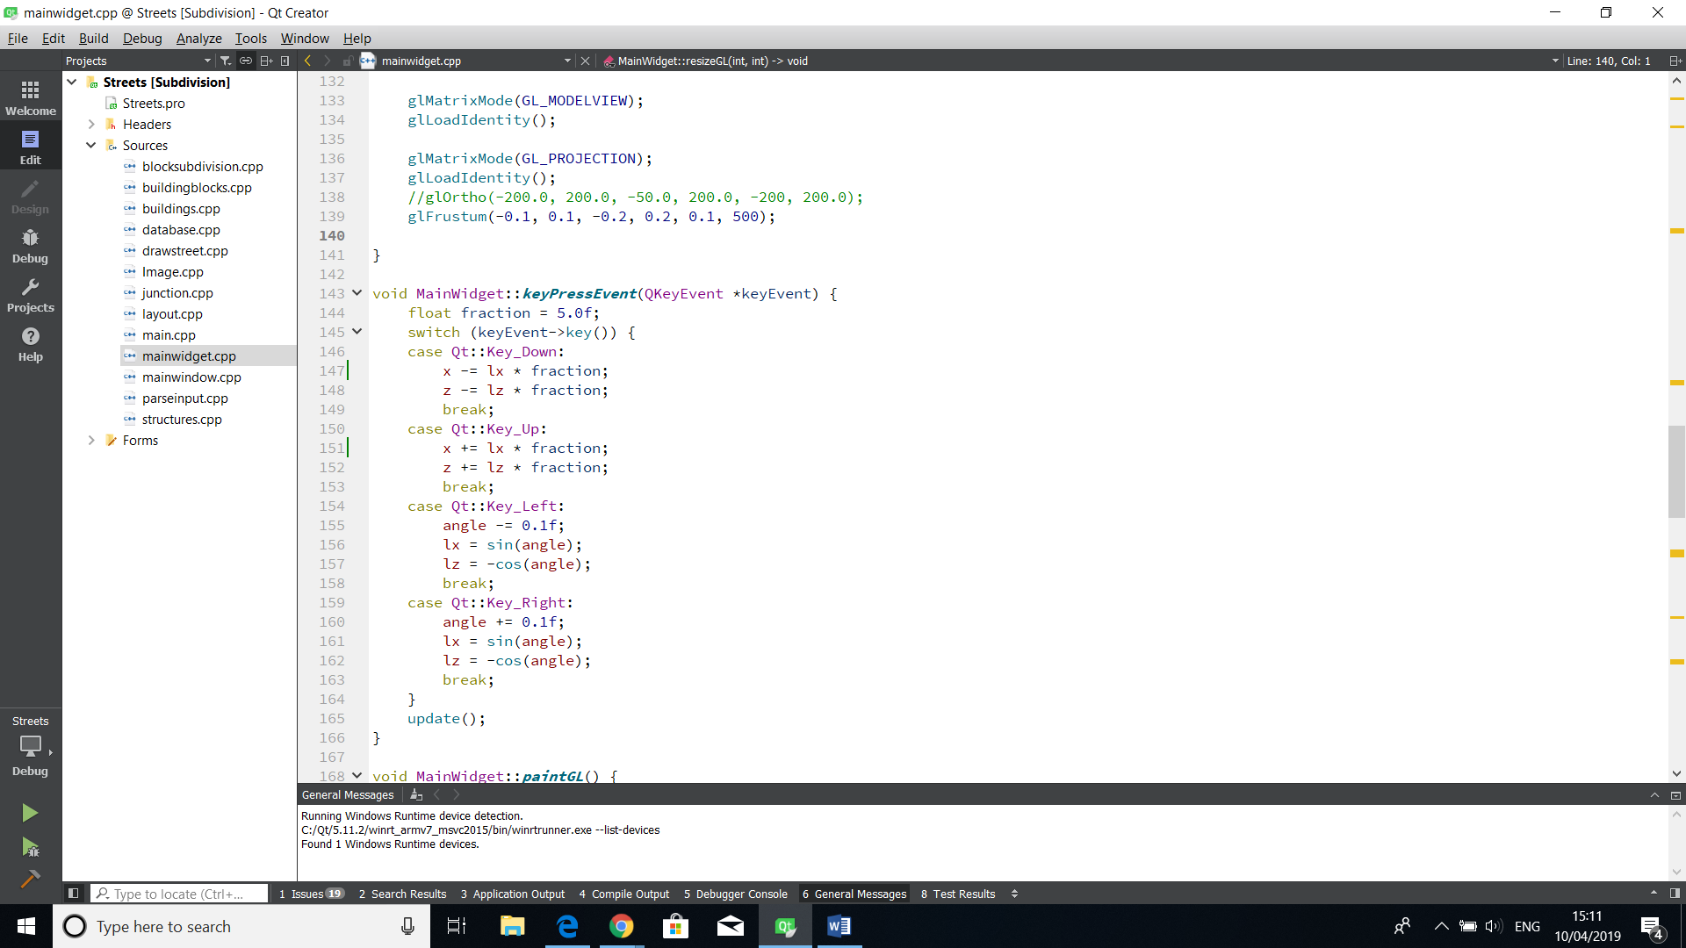

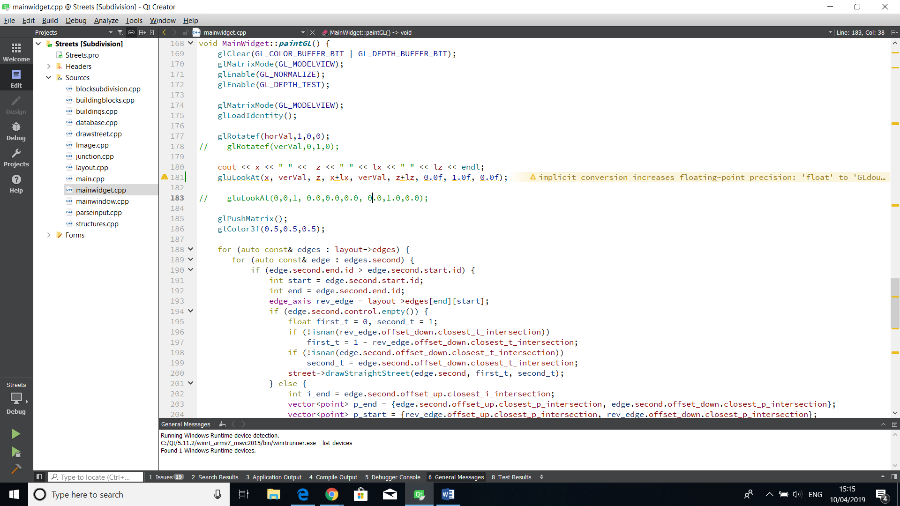

(arrows picture) (picture of the axis x,y,z and then can show how the camera rotates)

(pictures from different angles FPS, from higher)

Occasionally, users might prefer a more simplistic scene especially when the city gets too cluttered with buildings that obfuscate the street geometries. In such cases, changing the camera’s positioning might not be sufficient. For that reason, the interface includes a checkbox option for enabling and disabling building geometries.

(picture of on and off buildings)

Exporting the final model as a mesh is also a supported option. The model can be stored in a file with a standard 3D image format called OBJ which would contain a collection of polygon faces with vertices and edges. User can, then, open the file in their preferred 3D image editing program such as Blender, Maya or SketchFab and interact with the model even further.

(picture from sketchfab + the obj file)

The last feature of the interactive user interface is a real-time editing option which aims at giving users the opportunity to adjust the street network to their desires and expectations. However, the project’s plan intentionally didn’t allocate much time to this additional feature as it would deviate the project from its main objectives. Nevertheless, the editing can be applied to the points where streets join (i.e. the junctions) and would execute smoothly on a scale comprised of up to ? nodes. The functionality is enabled through a text box, which input determines the point to be edited, and two vertical sliders, which can move the selected point on the x or z axis. Movement of any of the two sliders would trigger an event which would move the selected point accordingly and reconstruct every object that has direct connection to it.

(multiple pictures of how the node is moving (with and without buildings))

(picture of the whole interface)

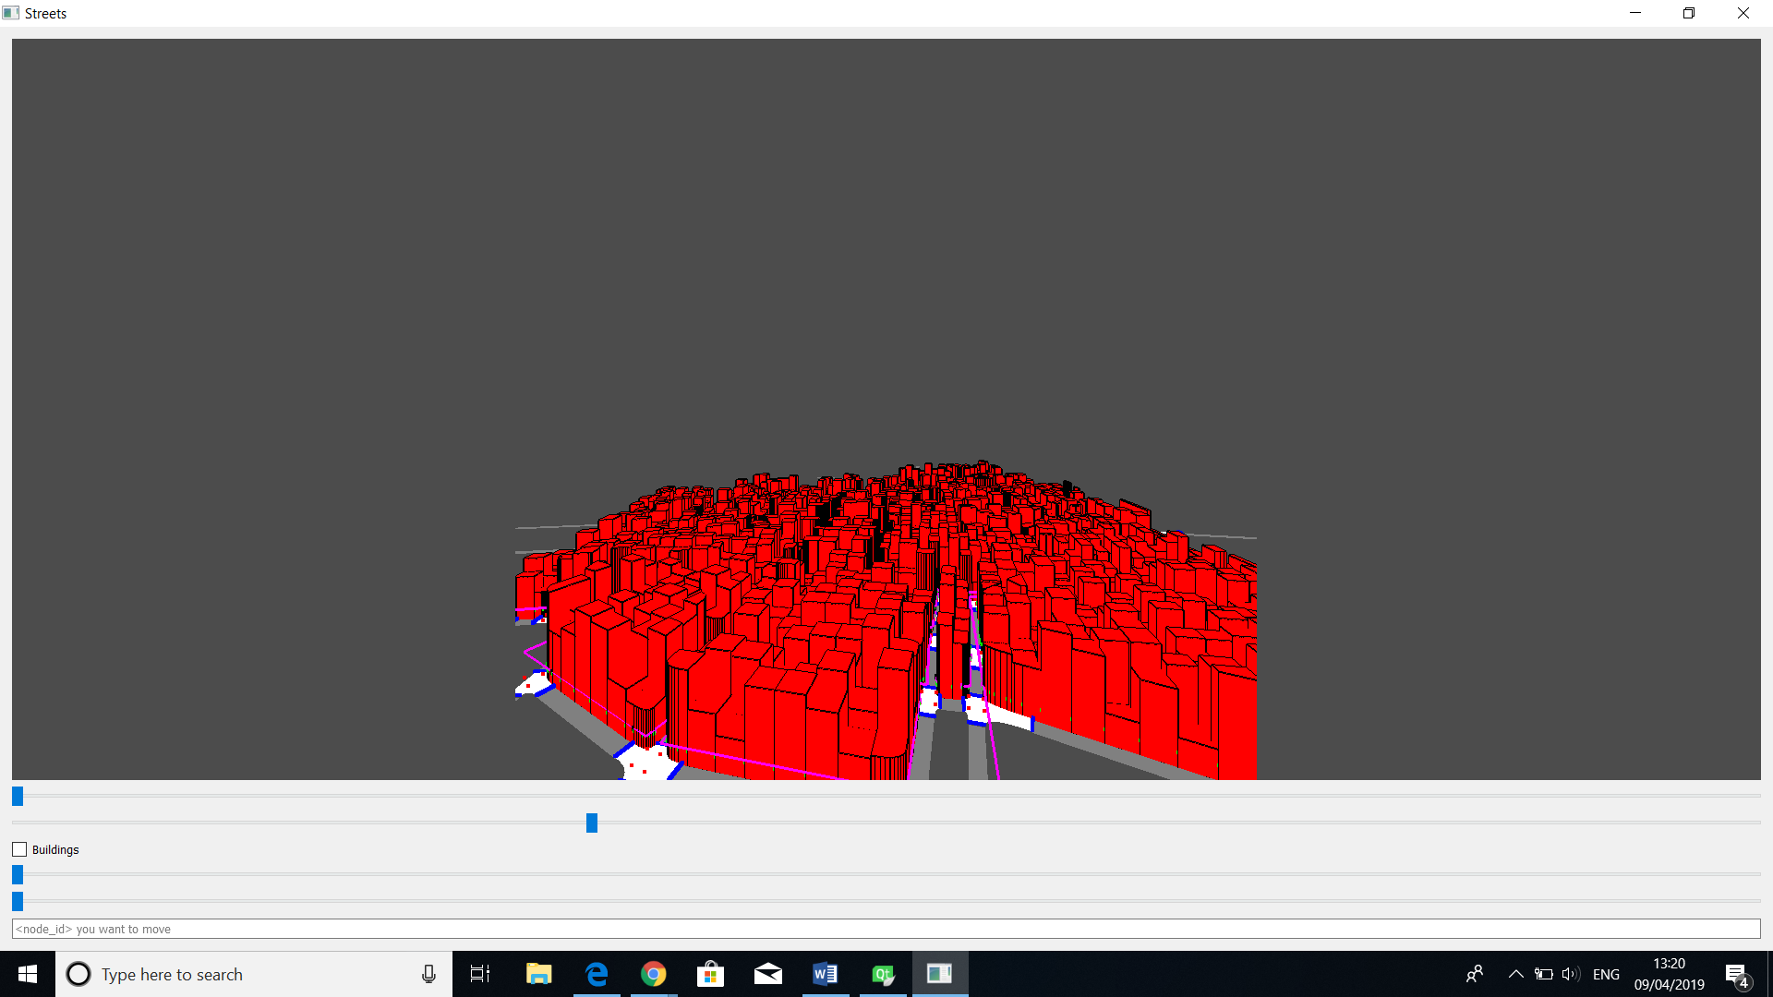

## 4.3 Code Structure and Workflow

This section focuses on the project’s software structure that formed a complete coherent system. Firstly, it will describe a high-level software workflow of the system and in subsections individually cover coding implementations of the chosen algorithms from (*Section 2*).

The high-level software workflow is depicted on *(Picture 1)* and shows the tasks the software performs to build a 3D city model. Note that steps (1, 2, 3) are only needed if a map has not been extracted yet or the user wants to change it. Furthermore, steps (5, 6) are optional and can be followed if a user wants to load the model into a 3D editor.

Assuming that the full workflow will be followed, the steps are as follows:

• Since the software bases its street network on a real geographic layout, the first step is to extract a geographic area from a map provider such as OpenStreetMap.

• To make that data understandable/assimilable? and omit unnecessary details, a parser needs to convert it. In our case, the extracted data is in OSM file format and gets converted to CSV.

• Then, the data can be inputted into the Main program that models and visualises the procedural city using appropriate techniques discussed in (*Section 2).*

• Lastly, the model can be exported as an OBJ and visualised into a 3D editor such as Blender, Maya and SketchFab.

(progressive images of how the city is developed)









### 4.3.1 Street Network Layout

As discussed in the overall structure, the first step of modelling a city is through extracting and parsing a region of a real geographic map. The implementation of this approach will be discussed in (Section 4.3.1.1) then (Section 4.3.1.2) will describe how the resulting output can be visualised in OpenGL.

#### 4.3.1.1 GIS Parsing

A region from the world’s map can be exported into a file using a software called OpenStreetMap as shown on (*Picture 1*). The file would have an OSM format that follows XML syntax (*Picture 2*) and would contain information about objects encompassed in the form of XML tags. For example, a certain object would be defined by a tag called “way” which would contain multiple other tags like “nd” and “tag”. The latter keeps the name of the object’s type that “way” defines (e.g. street, building, park, pond, etc.) whereas the former keeps a reference to another tag called “node” (*Picture 2*). A single “node” stores information about the location in latitude and longitude of a single point on a map. A “way” tag would, therefore, only include “node” tags that are part of the contour of the object that “way” refers to.

Knowing about the OSM file structure is important but it cannot be easily traversed by programming languages as it is. A parser containing formal grammar that is specifically designed for such files can extract and pass the meaningful information to a specific programming language. The project, therefore, makes use of a lightweight parser called ReadOSM in order to use the OSM information in C++.

Filtering and adapting the information provided was also required. Firstly, the project needed only tags that define streets, everything else had to be discarded. Then, streets had to be adapted to end when they intersect with another street, resembling a network. Furthermore, curved streets were not supported and were represented by multiple straight lines. Lastly, the locations were in latitude and longitude and had to be converted to pixel coordinates. All those concerns were resolved in the class ParseGIS (*Picture 3*).

• parseNode() and parseWay() used ReadOSM to find “node” and “way” tags which information was then stored in the variables nodes and ways. Any “way” tag that did not define a street and any “node” that was not part of a street got filtered out.

• divideWay() divide any street that intersected with another. That way streets would join into a single point rather than intersect each other and continue growing. At the end, the whole layout would resemble a network.

• convertCoordinates() converts the latitude and longitude coordinates to pixel coordinates preserving the relative distance of the objects. It is achieved by?

• convertCurve() detects a curved street and approximates its two control points to form a cubic Bezier curve

The resulting output from ParseGIS class would be a CSV file (*Picture 3*) that has the following structure:

• a set of nodes with x, y, z coordinates

• a set of control points with x, y, z coordinates

• a set of edges with reference to two node ids as well as reference to two control point ids if the edge is curved. The node ids are starting and ending points for the edge whereas the optional control points determine the curvature of a cubic Bezier curve.



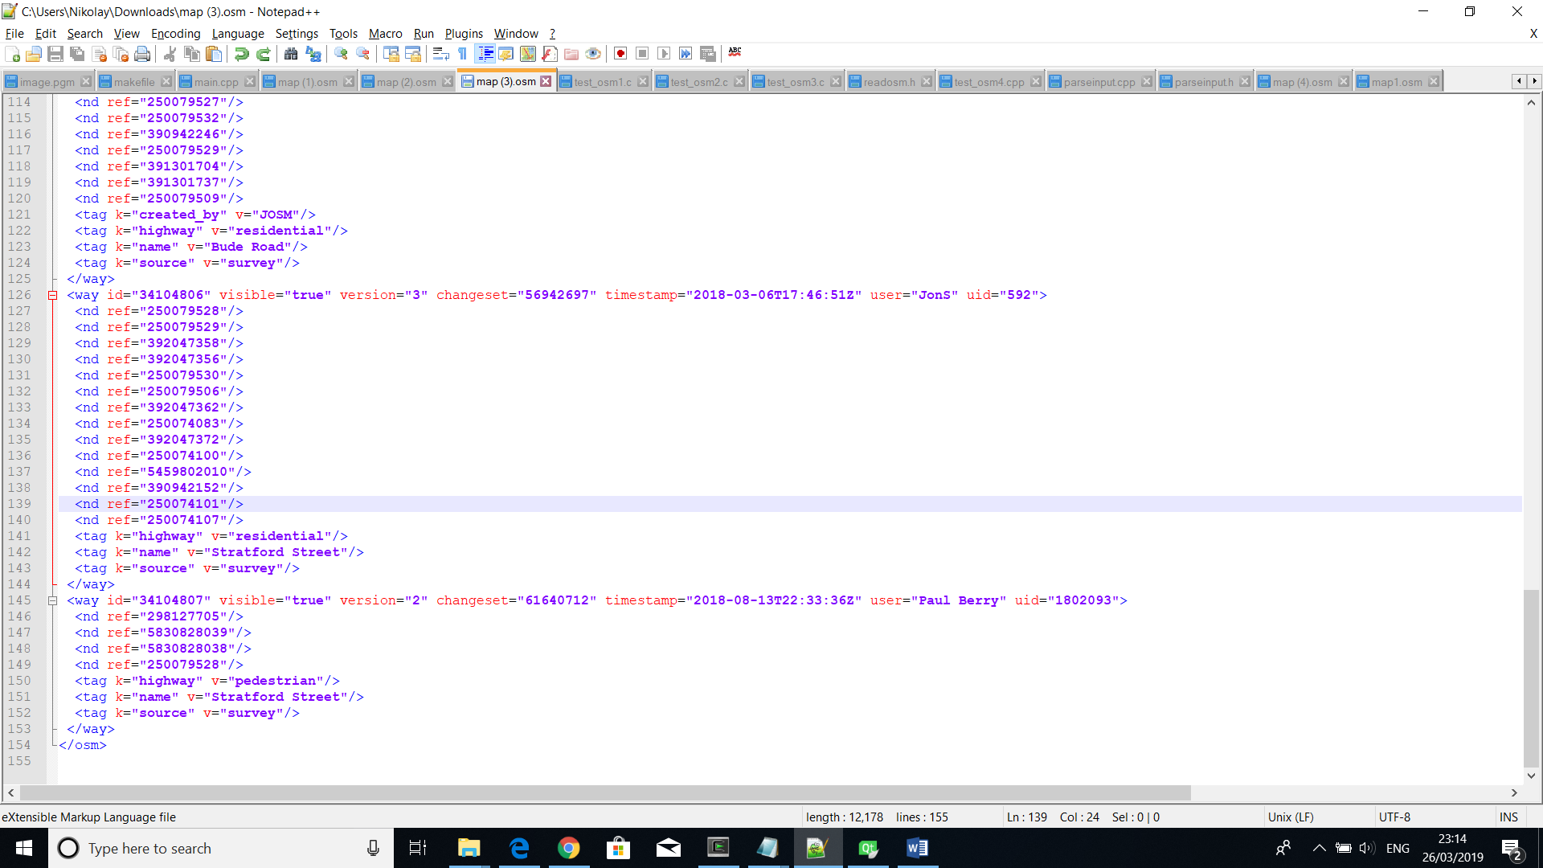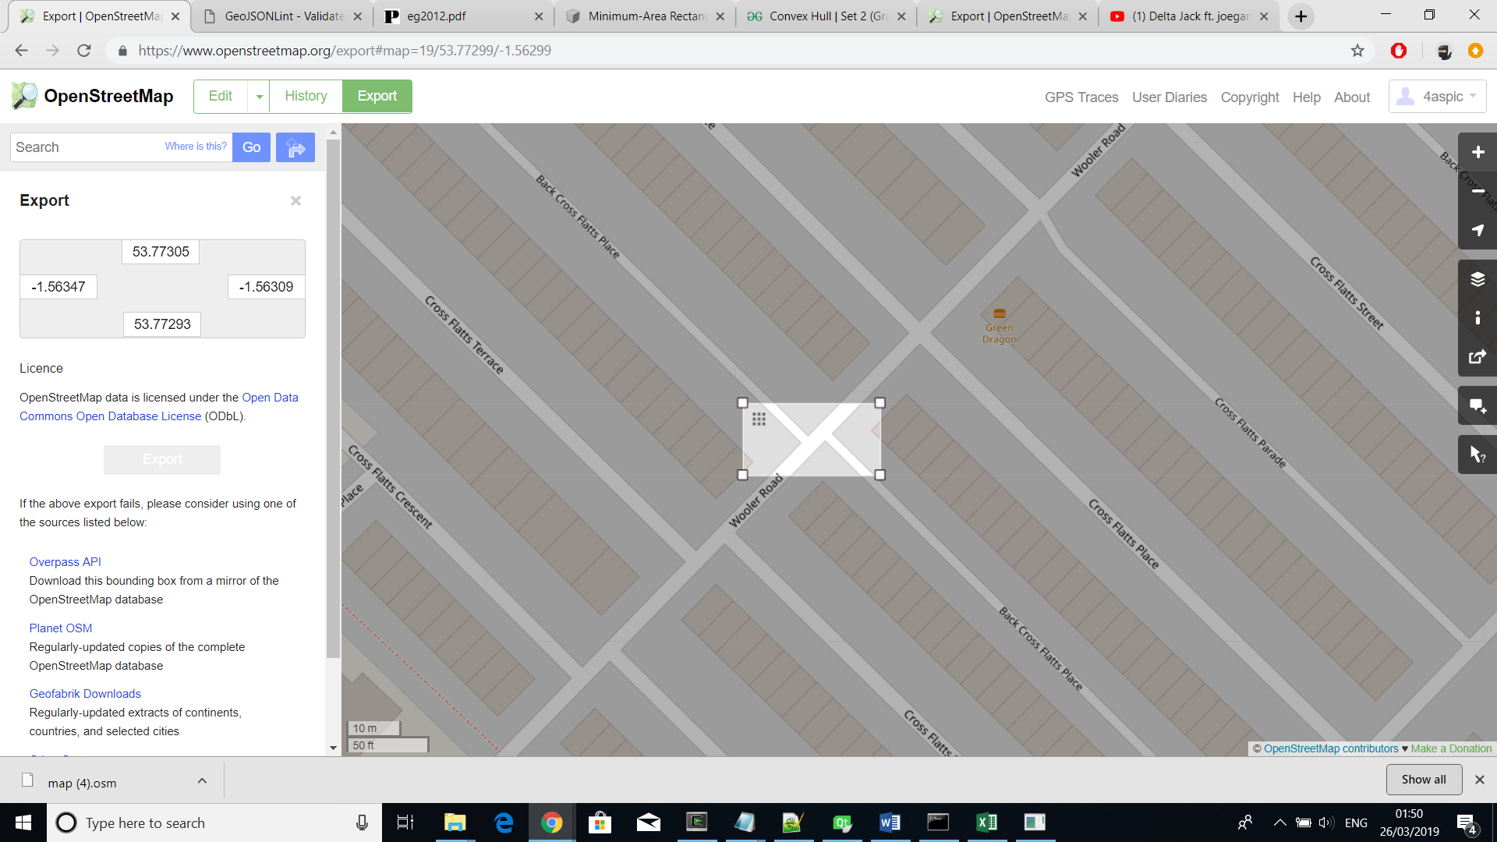

export parse

🡪 🡪

OpenStreetMap OSM File CSV File

#### 4.3.1.2 Layout implementation

After being parsed, displaying the exported map region in OpenGL is fairly simple (*Picture 1*). Three C++ structure types, “node”, “point” and “edge_axis” (Picture ?), provide the needed functionality to store the inputted street network. Similar to the CSV file, “node” has x, y and z values and “edge_axis” keeps a reference to a starting and ending node. In excel that reference was indicated by the line number while in C++ the “node” structure makes use of an additional variable called “id”. The support points, guiding a line’s curvature, are stored in the structure “point” with x, y and z values. This structure is used for all points that are not part of the nodes that define a graph network.

Rendering the edges can be done by applying the explained linear and cubic Bezier curve algorithms in (Section 2.2.1) on all instances of edge_axis (*Picture 1*). However, the project aims at rendering the streets with defined width and those algorithms would, therefore, be applied when each “edge_axis” undertakes certain modifications explained in (Section 4.3.2.1).



🡪 the streets but only lines

### 4.3.2 Street Network Segments

#### 4.3.2.1 Streets

As described in (*Section 2.2.2*), a line can be offset on both sides by its two opposite to each other normal vectors which would result to two other parallel to the original one lines. That technique moves points of a line toward the direction of its normal vector but finding the points comprising a line is explained in (Section 2.2.1). Both techniques require different steps for straight and curved lines which influenced the software implantation to have different methods, computeStraightStreet() and computeCurvedStreet(), for handling the different cases. A new structure type “edge_offset” stores the outputted lines which then get referenced by the “edge_axis” of the original line by the name of “offset_up” and “offset_down”. This whole referencing ensures that when an object changes, other instances that use it would know about and use its latest state (making the software easy to extend and robust).

After finding the variables “offset_up” and “offset_down” for all instances of “edge_axis”, they can be used to render street segments which is implemented in drawStraightStreet() and drawCurvedStreet() following the tessellation techniques described in (Section 2.2.2).

using GL_TRIANGLE_STRIP. Each point from the first line together with each point from the second get consecutively passed as a glVertex3f value to the OpenGL’s built-in function which uses them to form multiple triangles (Picture ?).

(add the tessellation picture here and don’t explain it previously)

(three pictures of how the simple lines are turned into streets – lines, offset lines, segments)

#### 4.3.2.2 Junctions

each node is a junction (where the edges/streets join)

explanation of how the pairs were found -> using the finding of loops

how the curve was found??

how the segment was found/traced

how the streets were cut -> considering the t

where the junctions were stored

### 4.3.3 Buildings

#### 4.3.3.1 Building Parcels

The algorithm explained in (*Section 2.4.1*) is implemented by the recursive method computeBlocks(). The returned values are sequences of node ids which get stored in a variable called “loops”. Knowing where the loops are is crucial but that is not sufficient. Size and shape of both street and junction objects need to be considered or buildings would overlap with them. The issue is resolved by computeBlocks() which rather than considering the edges between each two pair of nodes, considers their corresponding offset edge and junction curve.

For example:

Loop defined as sequence of node ids:

3, 6, 7, 1

Same loop considering streets and junctions:

3 (offset_up), 3-6 (junction curve), 6 (offset_up), 6-7 (junction curve), 7 (offset_up), 7-1 (junction curve), 1 (offset_up), 1-3 (junction curve)

It can be observed that the new sequence always uses the “offset_up” edge that was offset using a counter-clockwise normal vector. The reason is due to the counter-clockwise sequence of nodes which the algorithm from (*Section 2.4.1*) returned. Therefore, we know that offset_up would always be on the side of the referred to building area.

Other supporting methods are findAngle() which finds the angle between two vectors and removeLargestBlock() which removes the additional loop covering the outside boundary of the graph network. Furthermore, a variable called objects_p stores the updated building areas.

#### 4.3.3.2 Building Lots

Individual building areas can be determined through implementing the algorithm at (*Section 2.4.2*). As input is used the previously populated variable called objects_p where each large building area is comprised of counter-clockwise ordered points. The amount of points is decreased after finding the convex representation of each object through the method convexHull(). Then, smallestRect() finds their minimal bounding boxes.

The purpose of each box is to only find a division line for the inputted building area. Finding that line is accomplished by connecting the two middle points of both larger sides of the box. Since each building area is stored as a set of points, splitting the object in two can be accomplished by finding the connections of points that the division line intersects. Then, one of the objects will start from the first and end at the second intersection whereas the other will do the opposite.

For example:

input object - 1, 2, 3, 4, 5, 6

intersection passes between 2-3 and 5-6

resulting objects - i1, 3, 4, 5, i2 i2, 6, 1, 2, i1

(pictures showing that)

The division is handled by divideRect() method which terminates the recursive process when the object areas found by convexArea() become smaller than a certain threshold.

rectangle structure to store the minimal bounding box

can include the series of steps here?

maybe explain how the convex hull is found? no, pictures use it

#### 4.3.3.3 Building Objects

Building objects are modelled using the shape of the lot but with added random height on the y axis.

That would serve as a roof and its sides are polygons with

the tessellation for the roof is done using ?

the building is done by using the shape of the lot but with added height on the y axis

the sides of the building are done using polygons that use each neighbouring points of the object with height with the same two points from the object without height

the building objects are forming the shape of the building lot and get assigned random height

how are the lots made into objects with height -> describe short

a diagram showing how the classes are linked

extract map -> parse map -> store structured data in new file

main file -> main widget + other widgets for user control

main widget -> creates the layout (using the new file) -> offsets the streets -> finds the junctions -> finds the building parcels with respect to the new street objects and junctions -> subdivides the parcels -> finds the buildings -> paints everything -> export obj (optional)

sets the camera?; pairs

making the layout – GIS + nodes, edges..

making segments – subsections for streets and junctions

buildings –

couple of pictures showing the design – starting from layout then only streets then with junctions …

# Chapter 5 Testing

# Chapter 6 Results

# List of References

Graphics.ethz.ch. (2019). [online] Available at: <https://graphics.ethz.ch/Downloads/Publications/Papers/2001/p_Par01.pdf> [Accessed 17 Jan. 2019].

Citeseerx.ist.psu.edu. (2019). [online] Available at: <http://citeseerx.ist.psu.edu/viewdoc/download?doi=10.1.1.88.7296&rep=rep1&type=pdf> [Accessed 17 Jan. 2019].

Citygen.net. (2019). [online] Available at: <http://www.citygen.net/files/Procedural_City_Generation_Survey.pdf> [Accessed 17 Jan. 2019].

Sci.utah.edu. (2019). [online] Available at: <http://www.sci.utah.edu/~chengu/street_sig08/street_sig08.pdf> [Accessed 17 Jan. 2019].

Arxiv.org. (2019). [online] Available at: <https://arxiv.org/pdf/1801.05741.pdf> [Accessed 17 Jan. 2019].

Pdfs.semanticscholar.org. (2019). [online] Available at: <https://pdfs.semanticscholar.org/04f0/44da13e618ca8b399f004e713603e54e17cb.pdf> [Accessed 17 Jan. 2019].

<https://www.researchgate.net/publication/229707505_Procedural_Generation_of_Roads>

<https://www.researchgate.net/publication/220183520_Interactive_Procedural_Street_Modeling>

<https://www.researchgate.net/publication/260335265_Procedural_Modelling_of_Urban_Road_Networks>

<https://www.isprs-ann-photogramm-remote-sens-spatial-inf-sci.net/II-3-W5/409/2015/isprsannals-II-3-W5-409-2015.pdf>

<http://peterwonka.net/Publications/pdfs/2011.EG.Lipp.CityControl.final.pdf>

<http://citeseerx.ist.psu.edu/viewdoc/download?doi=10.1.1.88.7296&rep=rep1&type=pdf>

<http://hpcg.purdue.edu/papers/Benes11I3D.pdf>

Operational Urban Models State of the Art, M Wegner, <https://www.tandfonline.com/doi/abs/10.1080/01944369408975547>

<https://www.cs.williams.edu/~morgan/cs371-f12/gallery/5-Midterm/manhattan.pdf>

<https://www.researchgate.net/figure/From-left-to-right-A-scheme-of-L-system-6-its-application-to-the-simulation-of-algae_fig1_326251916> (tree)

<https://phiresky.github.io/procedural-cities/presentation.html#/highway-branching> (extended L-system pictures)

<http://www.cs.ru.ac.za/research/groups/vrsig/pastprojects/047proceduralmodelling/paper09.pdf> (voronoi)

# Appendix A External Materials

<Level 1 Heading with ‘heading 1’ Style Applied by Pressing Ctrl Shift 1> Text under appendix heading. Text under appendix heading. Text under appendix heading. Text under appendix heading. Text under appendix heading. Text under appendix heading.

## A.1 Level 2 Heading with ‘heading 2’ Style Applied by Pressing Ctrl Shift 2

Text under level 2 heading. Text under level 2 heading. Text under level 2 heading. Text under level 2 heading.

### A.1.1 Level 3 Heading with ‘heading 3’ Style Applied by Pressing Ctrl Shift 3

Text under level 3 heading. Text under level 3 heading. Text under level 3 heading. Text under level 3 heading.

#### A.1.1.1 Level 4 Heading with ‘heading 4’ Style Applied by Pressing Ctrl Shift 4

Text under level 4 heading. Text under level 4 heading. Text under level 4 heading. Text under level 4 heading.